Mechanism-Resolved Modeling and Adaptive Control of a Fanless Photovoltaic-Thermal Heat-Rejection Array
Jonathan Karl Bily
Cloud Wash Laundry Corporation, Canada
Corresponding author: Jonathan Karl Bily, Cloud Wash Laundry Corporation, Calle Xilaos 3, 44370 Cella, Teruel, Aragón, Spain. E-mail: jonathan@cloudwashlaundry.com
Running title: Fanless PVT heat rejection

Abstract
Data-center heat rejection consumes electricity through fans and water through evaporation. This study develops a mechanism-resolved numerical model of a 170 m² roof-mounted photovoltaic-thermal array operated at night as a fanless heat rejector. Seven switchable mechanisms are evaluated. Using air density in the droplet d²-law gives a 45 µm isolated-droplet lifetime of about 7 s at 5 °C and 55% relative humidity; whole-spray evaporation is nevertheless capped by the moisture-carrying capacity of the ambient air renewed through the overhead spray zone. With the panel tilt treated explicitly as 30° from horizontal, modeled capacity rises from 51.2 kW bare to 113.2 kW with all mechanisms active. Mist contributes about 4.8 kW. Ionic wind adds only about 0.8 kW while consuming 2.55 kW, a thermal coefficient of performance of about 0.30 and roughly 594 times the shaft power of an equal-area fan comparison. An ambient-adaptive controller meets a 100 kW duty on nine of ten representative nights and, through a 2 °C ambient freeze lockout, uses no water below freezing. Alternative convective-combination rules lower total capacity by 7–10%. Facility-scale analysis shows that roof-area matching governs deployment. Results remain design-stage estimates requiring experimental validation.
Keywords: photovoltaic-thermal; data-center cooling; natural convection; radiative cooling; evaporative cooling; electrohydrodynamic flow; adaptive control

Introduction
Every watt delivered to computing equipment ultimately leaves the building as heat. Mechanical dry coolers consume fan electricity, while wet systems consume water through evaporation [1, 2]. A hybrid photovoltaic-thermal (PVT) array offers a complementary route: the roof area already exists, is electrically idle at night, and can reject heat by convection and by long-wave radiation to a sky that can lie well below ambient temperature [3, 4].
Proposals of this kind usually bundle several augmentations together and report a single aggregate performance figure. That is not useful for design. An engineer needs to know which mechanism supplies which fraction of the capacity, what each costs in water or electricity, which are worth building, and how the combination should be operated as conditions change. This paper therefore models seven mechanisms separately and switchably, and adds the controller that apportions them.
Night-time PVT cooling has experimental precedent. Eicker and Dalibard measured approximately 60–65 W m⁻² while uncovered PVT collectors cooled a warm storage tank [20]. The present work does not treat that study as validation of this architecture, but uses it as an external order-of-magnitude benchmark. The analysis then asks which additional mechanisms materially improve a fanless array and at what electrical or hydraulic cost.
Methods
Array, mechanisms and operating point
The modeled array comprises 100 panels of 1.70 m², totalling 170 m², inclined at 30° with a 0.10 m sub-panel plenum discharging into a draft stack. Figure 1 shows the arrangement and the location of each mechanism. The baseline condition is a clear winter night: air 5 °C, relative humidity 55 %, wind 1.5 m s⁻¹, cloud fraction 0.0, panel surface 35 °C.

Sky model
Effective sky temperature follows from an emissivity computed from dew point by the Berdahl–Martin clear-sky correlation [5], corrected toward black-body overcast in proportion to cloud fraction:
ε_sky = ε_clear(T_dp) + (1 − ε_clear) c ε_cloud , T_sky = T_amb ε_sky^(1/4) (1)
At the baseline condition this gives a dew point of -3.3 °C, sky emissivity 0.693 and an effective sky temperature of -19.3 °C. Because the selective emitter's advantage arises from transmittance through the atmospheric window, that advantage is scaled by (1 − c) and vanishes under full overcast, as it must.

Convective, radiative and evaporative pathways
Natural convection uses the Churchill–Chu vertical-plate correlation [6] with the standard inclination correction described in heat-transfer texts [7]. The stored panel tilt β is measured from horizontal, so the buoyancy term uses g sin β (equivalent to g cos θ when θ is measured from vertical). Forced contributions use the mixed flat-plate correlation [7]. The plenum, shroud and ionic-wind velocities each generate a forced coefficient, combined with natural convection in quadrature:
h_conv = ( h_nc² + h_plenum² + h_shroud² + h_EHD² )^(1/2) (2)
Quadrature is used as the reference rule because the stack, shroud and ionic-wind velocities act on overlapping flow over the same surface rather than on independent surfaces. Power-law combinations of mixed natural and forced convection are often written with an exponent of 3 [7], so an exponent-3 combination, and a rule that combines the forced velocities before computing a single forced coefficient, are reported as model-form sensitivities. Buoyant velocity balances thermal head against a lumped loss coefficient, giving the square-root dependence on stack height and temperature difference predicted by the reduced-order stack model:
v_stack = [ 2 g H (ΔT / T_amb) / K ]^(1/2) (3)
Radiative exchange uses the gray-body form with the emitter advantage as an additional sink depression; evaporative flux uses the Chilton–Colburn analogy [8] at a Lewis number of 0.865. Two-phase thermosiphon spreading [9] is represented as an increase in area utilisation from 0.75 to 0.97, reflecting a more nearly isothermal surface.

Electrohydrodynamic (EHD) Ionic Wind
Space-charge drift in a DC corona field exerts a body force on neutral gas [10, 11]. Recent reviews of corona-wind heat-transfer enhancement and ionic-wind physics emphasize that useful local airflow is possible but electrical efficiency, ozone, electrode durability and geometry remain critical constraints [21, 22]. The present reduced-order model integrates the electrohydrodynamic pressure rise over the electrode gap and applies a momentum-recovery efficiency to obtain useful surface velocity.
Δp = J d / µ_ion , v_EHD = η_m ( 2 Δp / ρ )^(1/2) (4)
with ion mobility µ_ion = 2.0 × 10⁻⁴ m² V⁻¹ s⁻¹, gap d = 20 mm and electrode potential 15 kV. Electrical power is V J per unit area. Ozone is generated in proportion to discharge power at 5 g kWh⁻¹, a conservative positive-corona figure [12], and reduced by a catalytic converter of 98 % efficiency in the modeled design. For comparison the model also computes the shaft power a fan would need to deliver the same volumetric flow against the same head.

Mist array, film and water balance
Droplet flight uses a d²-law mass-transfer model [14], terminal velocity from a standard drag correlation [15], and wet-bulb temperature from air temperature and relative humidity [13]. The evaporation constant is proportional to air density rather than water-vapor density. For an isolated droplet, K_e = 8 ρ_air D_v ln(1+B_M)/ρ_w and τ = d₀²/K_e. Because an array injects many droplets into a finite air stream, isolated-droplet kinetics are then capped by the psychrometric moisture capacity, between the inlet humidity ratio and saturation at the wet-bulb temperature, of the ambient air renewed through the spray zone above the array. Because the nozzles are overhead, that air is not the sub-panel plenum flow; it is taken as ρ_air U H_s W_p, where H_s is the 1.2 m nozzle height, W_p is the plan width of the array (√(A cos β) ≈ 12.1 m) and U is the ambient wind speed, with a minimum exchange velocity of 0.3 m s⁻¹ representing buoyant and entrainment renewal on calm nights. The exchange flow is varied by factors of 0.5 and 2 in the sensitivity analysis. Liquid remaining after that bulk-air cap is apportioned between panel interception and carry-over. Surface evaporation is separately limited by heat and mass transfer at the panel and by geometric wetting; recovered runoff is credited through the stated recovery efficiency. Film and mist are locked out whenever ambient air temperature is below 2 °C.

Controller
The four passive mechanisms have no operating cost in the model and are always enabled. The controller searches the three consumptive settings — film duty, mist duty and ionic-wind setting — and selects the least-cost combination that meets the target duty while holding A-weighted sound pressure at the receiver below a 45 dB(A) limit. Cost combines make-up water and ionic-wind electrical energy at stated tariffs; hydraulic parasitics for coolant circulation and film or mist pumping are not part of the objective (Limitation 11). Where no combination meets the duty, the highest-capacity acoustically legal option is returned and flagged as capacity-limited. Inputs are air temperature, wind speed, sky clarity and humidity.

Reference plants, acoustics and uncertainty
Fan sound power for the reference dry and evaporative coolers uses the specific sound-power method [16, 17], with air flow set by each plant's thermal duty. Nozzle sound power is scaled from single-nozzle data; buoyant and corona sources are treated as negligible in the screening calculation [18]. Levels are propagated hemispherically to a receiver at 10 m and summed energetically with a 35 dB(A) night background. Because the acoustic source uncertainties are not experimentally constrained on the same basis as the deterministic calculation, a probabilistic acoustic interval is not reported; uncertainty discussion instead uses explicit parameter sensitivities.

Results

Mechanism attribution
Table 1 and Figure 2 build the array up one mechanism at a time from a bare tilted panel. With the inclination convention stated explicitly, capacity rises from 51.2 kW to 113.2 kW, a factor of 2.21. The largest increments are the evaporative film (+22.4 kW) and thermosiphon area spreading (+17.0 kW). The mist contribution is +4.8 kW because droplet kinetics and bulk-air saturation are treated separately.

Draft-stack height
Because buoyant velocity scales as the square root of stack height, capacity gains show strong diminishing returns. Figure 3 plots capacity and stack velocity against height, and the marginal return per additional meter normalized to the 1.0–1.5 m reference increment. On the 0.5 m design sweep, marginal return falls to 50% at about 4.5 m and to 20% at about 20.0 m.
These thresholds provide a thermal design bracket rather than fixed structural recommendations. A stack of roughly 4.5 m captures much of the available marginal benefit; by roughly 20 m the incremental gain per additional meter has fallen to about one fifth of the low-height reference. Structural, wind-loading, planning and cost constraints are outside the thermal model, so heights in this range require site-specific engineering.

Shrouds and the buoyancy–wind transition
Figure 4 shows that the model supports complementary buoyancy and wind regimes. At the design shroud speed-up of 1.6, buoyancy supplies about 59% of the modeled convective coefficient in still air and its share declines monotonically as wind increases, reaching about 3% at 6 m s⁻¹.
The practical consequence is that shroud design should be evaluated at the site's wind rose, not at a single design point. At the baseline 1.5 m s⁻¹ the shrouds add about 3.0 kW, but at 6 m s⁻¹ raising the speed-up from 1.0 to 2.2 produces a much larger convective increase. A site with reliable nocturnal wind justifies more aggressive shroud geometry; a sheltered site does not.

Deployable selective emitter and sky clarity
Radiation is the dominant pathway in dry operation, and its magnitude depends strongly on sky state. Figure 5 compares stowed and deployed emitter flux across the representative conditions. Deploying the selective emitter rather than exposing an ordinary backsheet raises total flux by between 1.02× and 1.58× depending on conditions. The gain is largest under clear skies and effectively vanishes under overcast, where the atmospheric window closes and the sky approaches a black body at near-ambient temperature.
This has a direct control implication: a deployable emitter is most valuable under clear skies and much less valuable under overcast conditions. The result also means that a fixed 12 K selective-emitter sky-temperature advantage should be treated as an assumption to be tested, not as a measured property of a finished device.

Electrohydrodynamic ionic wind is not worth its power
At full setting the corona discharge induces a modeled surface velocity of 0.139 m s⁻¹ from a 0.100 Pa static head. On the same wet operating point used in the mechanism ladder, it adds about 0.8 kW while consuming 2.55 kW of electrical power, giving a thermal coefficient of performance of about 0.30. The consumed electricity would itself ultimately become heat that must be rejected, so the reference design remains energetically unfavorable.
For a consistent comparison, both electrohydrodynamic and fan power are evaluated on the same distributed 170 m² basis (Figure 6). An idealized fan delivering the same modeled flow against the same 0.100 Pa head requires about 4.3 W, so the EHD system uses approximately 594 times more electrical power. Post-catalyst ozone emission is 0.255 g h⁻¹ and requires site-specific dispersion assessment [19].
The result is a clear negative for array-wide EHD augmentation, with the electrical-power disadvantage amounting to roughly 2.8 orders of magnitude relative to the equal-area idealized fan comparison. Corona wind may remain relevant for localized hot spots or geometries where conventional air movement is impractical; recent literature documents such small-scale heat-transfer applications [21].

Droplet flight: isolated-droplet kinetics and whole-spray saturation
The evaporative pathways are the largest contributors to capacity and the only ones that consume water, so they warrant closer treatment. The intuitive purpose of an overhead spray is adiabatic pre-cooling: evaporate water into the incoming air, depress its dry-bulb temperature toward the wet bulb, and gain driving temperature difference. That intuition fails in the regime this architecture targets.
At the baseline condition a 45 µm isolated droplet has a terminal velocity of about 6.0 cm s⁻¹ and a fall residence time of about 20.0 s. With air density used in the d²-law, its isolated-droplet evaporation lifetime is about 7.0 s, so an isolated droplet would evaporate before reaching the panel. Figure 7 shows the isolated-droplet evaporated fraction against droplet size for three ambient conditions.
An isolated-droplet result cannot, however, be applied to every droplet in a dense spray without checking the receiving air. At baseline nozzle flow, the air renewed through the spray zone reaches its psychrometric moisture capacity before all injected water can evaporate. The coupled model therefore limits whole-spray in-flight evaporation to about 51% at the baseline design point, with the remaining liquid available for interception or carry-over. The mist is thus neither purely an air pre-cooler nor purely a film-delivery system; the balance depends on droplet size, airflow, humidity and injection rate.
This result changes the design interpretation relative to a simple film-delivery assumption. Smaller droplets can improve isolated evaporation but may reduce reliable surface delivery, while larger droplets favor film formation but provide less air pre-cooling. Nozzle selection should therefore be optimized jointly for psychrometric capacity, deposition, carry-over and surface wetting.

Nozzle row saturation
Increasing the number of nozzle rows shows a saturation point at three rows (Table 2). In the mist-only, continuous-operation sweep used for that table, one row produces essentially no surface wetting because its whole flow evaporates within the spray-zone air, two rows wet about 58%, and three rows reach the 92% geometric limit. Additional rows then increase make-up flow without adding modeled heat-rejection capacity.
Table 2 is intentionally a mist-only diagnostic and is therefore not directly comparable with the cumulative mechanism ladder in Table 1. The reference two-row design is a conservative water/nozzle-count choice rather than a capacity-maximizing layout; three rows are shown to identify the geometric wetting ceiling.

The capacity–water Pareto front
Sweeping the common film/mist duty traces a Pareto front between rejection capacity and water economy (Figure 8). The dry passive array rejects 85.3 kW. At the reference duty of 0.35 the array reaches 112.5 kW, a 1.32× gain, while using about 38% less water than a reference evaporative cooler sized to reject the same heat. At high wetting duty the present assumptions can consume as much or more make-up water than the reference cooler, so continuous wetting is not a water-saving operating point.
Using a consistent 85% water-reduction target, the model reaches that target at a common wetting duty of about 0.068, with a capacity gain of about 1.06×. Holding the reference-duty heat rejection of 112.5 kW at that water target would require approximately 211 m² rather than the 170 m² reference array.
This is a constraint rather than a benefit: a large water saving and a large capacity gain are not simultaneously available from this architecture. Any design report quoting both must state the operating point at which each was measured, and the two figures will not be the same point. The correct design response is a controller that moves along the front according to which resource is scarce — which is precisely what the controller analysis below demonstrates.

Controller behavior across the operating envelope
Table 3 and Figure 9 show the controller's selections across ten representative nights at a 100 kW target duty. The behavior is exactly what the physics implies and what an operator would want.
Below the 2 °C ambient freeze lockout the array runs completely dry, consuming no water, and still meets or exceeds the target duty—reaching 150.4 kW on the coldest night modeled. This is the regime the architecture is built for: the radiative sink is deepest, the temperature difference is largest, and the evaporative mechanisms are neither needed nor safe to operate. On cool and mild nights the controller admits film wetting at partial duty and occasionally a little mist. Only on warm and humid nights does it run the evaporative pathways hard.
Ionic wind is selected only in the warm clear summer condition, where the controller is capacity-limited even with aggressive augmentation. The maximum there is about 63.6 kW against the 100 kW target. This is the boundary of the concept: a real installation requires conventional capacity in parallel for warm conditions.

Acoustics
Figure 10 compares the modeled levels. The reference dry and evaporative coolers produce 60.5 and 60.3 dB(A) at 10 m. The three mist-active controller cases give total modeled levels of 39.8, 39.8 and 45.4 dB(A), an arithmetic mean of about 41.6 dB(A). Controller modes without mist are background-dominated at about 35.0 dB(A) because the screening model assigns no separate acoustic source to the water film. These are modeled sound levels; no acoustic measurements were performed.
Using the mist-active arithmetic mean, the margin relative to the 60.3 dB(A) evaporative-cooler reference is about 18.6 dB. The warm summer case has an apparatus-only source level of 45.0 dB(A), which satisfies the controller's 45 dB(A) apparatus-source constraint, while energetic addition of the assumed 35 dB(A) background raises the reported total to 45.4 dB(A). The controller therefore constrains equipment emission before ambient background is added for observer-level reporting.

Uncertainty
A probabilistic acoustic margin is not reported because the relevant source uncertainties have not been experimentally constrained on the same basis as the deterministic 10 m comparison. Figure 11 instead reports direct sensitivity of the two largest assumed passive gains. Varying thermosiphon area utilization from 0.80 to 0.97 changes its modeled increment from about 3.9 to 17.0 kW. Varying the selective-emitter sky-temperature bonus from 0 to 12 K changes its increment from about 1.8 to 6.8 kW. These ranges show that both headline passive gains require experimental constraint. Two model-form choices were also tested. Replacing the quadrature rule with an exponent-3 combination lowers baseline capacity from 113.2 to 102.4 kW, and combining the forced velocities before computing a single forced coefficient gives 105.2 kW. The evaporative film and thermosiphon spreading remain the two largest increments and ionic wind remains negligible, but the stack increment falls from 7.3 kW to 3.8–4.7 kW and the controller meets the 100 kW duty on 7 rather than 9 of 10 nights, additionally falling short on the warm humid (90.6–93.1 kW) and cold winter (92.6–94.8 kW) nights. Halving the spray-zone air exchange lowers in-flight evaporation to about 25% and raises the mist increment to 10.6 kW; doubling it allows complete in-flight evaporation, leaves the mist increment at 4.7 kW and reduces the nights meeting duty to 8 of 10. The convective-combination rule is therefore a first-order uncertainty in absolute capacity.
Water demand is likewise operating-point dependent rather than a single property of the hardware. The controller uses no water below freezing, approximately 0.47 m³ over 12 h on the baseline clear 5 °C night, and about 1.46 m³ on the warm humid night. Those values should be interpreted as model outputs at the selected controller states rather than fixed consumption rates.

Deployment scale: where the benefits actually land
The array rejects approximately 502 W m⁻² in dry mode and 661 W m⁻² at the baseline wet reference point. A data center produces heat at a flux set by power density and usable roof area, so deployment remains fundamentally an area-matching problem. Figure 12 places each facility archetype against these two capabilities.

Method and archetypes
Eight illustrative archetypes were constructed around reported rack densities. Average rack density rose from about 16 kW in 2025 to 27 kW in 2026, and 50–70 kW racks are now common in artificial intelligence (AI) deployments [23]; a current-generation graphics processing unit (GPU) rack such as the GB200 NVL72 requires about 120 kW of cooling capacity [24]. Facility dimensions, power usage effectiveness, on-site heat recovery and roof-utilization fractions are illustrative assumptions rather than survey observations. White space is allowed at 3.0 m² per rack including aisles, and taken as roughly half of gross floor area for large facilities. Roof area is footprint divided by storeys, multiplied by a usable fraction of 0.60–0.75 to exclude plant, walkways, skylights and setbacks. Heat to reject is IT load multiplied by power usage effectiveness, less any fraction usefully recovered on site.
Two outcomes are then computed. Water saving follows directly from the displaced evaporative duty. Boundary noise is computed by re-sizing the residual mechanical plant to the uncovered load, recomputing its fan sound power, propagating to a boundary distance set by the parcel size, and summing energetically with a 35 dB(A) night background.

Area matching
Table 4 gives the result. An AI training hall of GB200-class density must reject 9583 W m⁻² of usable roof — roughly 19 times what the dry array can deliver — so roof coverage reaches only 5.2%. A conventional hyperscale facility at 2026 average rack density is less extreme but still reaches only 28.2%. Full coverage would require 19.1× and 3.5× the available roof respectively.
At the other end, a micro installation co-located with a laundromat rejects only 90 W m⁻² of roof, and a car wash about 58 W m⁻². Both are far below what the array delivers even in dry mode. Coverage is complete, and the array needs only about 18% and 12% of the available roof respectively. Two effects compound here: the load is small in absolute terms, and a substantial fraction of the waste heat is usefully consumed on site — pre-heating laundry or wash water — so it never reaches the rejection plant at all.

The asymmetry between water and noise
The two benefits do not scale together, and this is the central result of the section. Water saving is linear in coverage: absorbing a fraction f of the load displaces a fraction f of the evaporative duty. Acoustic benefit is logarithmic, because the residual mechanical plant still runs and fan sound power falls only as
ΔL_W = −10 log₁₀ (1 − f) (5)
Figure 13 plots both relationships. A 3 dB reduction — the smallest change most listeners reliably notice — requires 50 % coverage. A 10 dB reduction, conventionally judged half as loud, requires 90 %. Below about 25 % coverage the acoustic benefit is under 1.2 dB and is effectively unmeasurable against ambient variation.

Consequence for mega-scale facilities
At hyperscale the array is primarily a water technology, not an acoustic one (Figure 14). Across the four large archetypes, dry roof coverage of 5.2–28.2% yields proportional water displacement in dry-array operation but boundary noise reductions of only 0.2–1.4 dB. For the AI training hall the acoustic benefit is about 0.2 dB, smaller than normal night-to-night variation in ambient background.
Ground-mounting can materially increase coverage but does not automatically eliminate mechanical plant. Allocating a quarter of the non-building parcel raises conventional-hyperscale coverage to about 61%. At that coverage the idealized sound-power reduction is about 4.1 dB: above the paper's nominal 3 dB perceptibility threshold, but still far short of the 10 dB reduction associated with 90% coverage.
Accordingly, large-facility deployment should be evaluated primarily as a water-reduction strategy; the modeled acoustic benefit remains small unless load coverage approaches the regime in which the residual mechanical plant can be substantially downsized.

Consequence for micro installations
At micro scale the conclusion inverts. Coverage is complete for all three micro archetypes, so the mechanical rejection plant is not merely quieter but absent. Boundary level falls from 51.7 dB(A) to the 35 dB(A) background for the laundromat case and from 49.2 to background for the car wash, reductions of 16.7 and 14.2 dB, corresponding to perceived loudness ratios of 3.2× and 2.7×. Water consumption for heat rejection goes to zero on nights when the controller runs dry, which for the cold-season operating regime is most of them.
The reason is not that the array performs better at small scale — the flux is identical — but that the area ratio inverts. A laundromat has a large roof relative to a 50 kW compute load, and a car wash more so. The required rejection area is only about 18% and 12% of the available roof respectively, leaving the remainder available for conventional photovoltaic generation.
This matters beyond noise. A micro data center whose rejection plant is silent and waterless can be sited in a mixed-use or residential setting where a conventional facility could not obtain planning consent, and can operate through the night without a noise curfew. Combined with the on-site thermal recovery that reduces the rejection duty in the first place, the small-scale case is where this architecture is at its strongest — and it is the case least represented in the data-center cooling literature, which is written almost exclusively around hyperscale.

The crossover
The regional edge facility sits at about 72.6% dry coverage and a modeled 5.6 dB boundary-noise reduction. The practical full-coverage threshold follows directly from the dry-array capability: a facility requiring no more than about 502 W m⁻² of usable roof can, in principle, be fully covered under the baseline dry condition.

Discussion

Which mechanisms to build
Mechanism resolution produces a useful build ranking. Thermosiphon spreading and the selective emitter together add about 23.8 kW under their reference assumptions; the plenum/stack adds 7.3 kW and shrouds 3.0 kW at the baseline wind. The evaporative film adds 22.4 kW and the mist stage 4.8 kW at the stated design duties. EHD adds only about 0.8 kW for 2.55 kW of electrical input and is not supported for array-wide use.

The value of adaptive control
The controller results show why a fixed operating point is inappropriate. The same hardware uses about 1.46 m³ over a 12 h warm humid night, about 0.47 m³ on the baseline clear 5 °C night, and no water below freezing while targeting the same 100 kW duty. Water use is therefore a control outcome, not a constant equipment specification.

Where the concept fails
Two boundaries emerged that were not visible before the mechanisms were separated. The first is summer: the array cannot meet duty on a warm clear night even at full augmentation, so it is a supplement to conventional plant rather than a replacement. The second is footprint: 170 m² of array delivers on the order of 100 kW, which is attractive only where the roof is already committed to photovoltaics and thermally idle at night, and unattractive where area must be purchased for the purpose.

Limitations
(1) The model is lumped, quasi-steady and one-dimensional, built from reduced-order correlations rather than computational fluid dynamics. Absolute fluxes remain uncertain and no prototype of the combined apparatus has been experimentally validated. Eicker and Dalibard [20] provide an external order-of-magnitude benchmark rather than a calibration target: their Madrid installation measured 60–65 W m⁻² when cooling a warm storage tank and 40–45 W m⁻² when cooling a ceiling; they also report about 41 W m⁻² average summer radiative cooling under central Spanish conditions with an average tank temperature of 20.9 °C. Because the present model does not reproduce their simultaneous ambient, wind, sky and fluid conditions, no single matching panel temperature is imposed.
(2) Mechanism increments are order-dependent because the pathways interact: the evaporative increment quoted assumes the convective and radiative mechanisms are already active, and would differ if added in another sequence. The ladder should be read as an attribution under one build order, not as independent additive contributions.
(3) The ionic-wind model uses a lumped momentum-recovery efficiency rather than a resolved discharge and flow field. The equal-area comparison penalizes EHD by about 594× relative to the idealized fan shaft power, so its array-wide energetic conclusion is robust, but the absolute velocity and local heat-transfer enhancement require experiment or resolved electrohydrodynamic simulation.
(4) The selective-emitter advantage is represented by a sky-temperature depression scaled by cloud fraction, not by spectral integration against measured atmospheric transmittance. Sensitivity analysis shows that changing this assumed bonus from 0 to 12 K changes the emitter increment from about 1.8 to 6.8 kW. The reference value should therefore be regarded as a design hypothesis until measured.
(5) Interception, gravity recovery efficiency and wind carry-over are lumped empirical parameters with no measured basis for this geometry, and are among the most influential and least constrained inputs.
(6) Nozzle sound power is scaled from single-nozzle manufacturer data assuming incoherent summation; array effects, panel-plane reflection and spectral content are not modeled. Corona acoustic emission is assumed negligible without measurement.
(7) Water chemistry appears only as a cycles-of-concentration parameter. Biofouling, scaling on the emitter surface, and the optical degradation that surface deposits would cause to both photovoltaic and radiative function are not modeled and could be operationally decisive.
(8) Freeze management is a simple lockout that prevents wetting whenever ambient air temperature is below 2 °C. It trades capacity for freeze safety: at −1 °C, 60% relative humidity, 1 m s⁻¹ wind and 50% cloud, locked-out dry operation gives about 84.9 kW against the 100 kW target. Transient behavior of a wetted surface near 0 °C, including possible ice accretion in the plenum or gutter, is not modeled.
(9) The controller optimizes a static cost function at a single instant. Thermal capacitance, mode-switching hysteresis, actuator lifetime for the deployable emitter, and the dynamics of demand tracking are all outside the present scope.
(10) Coolant temperature is not solved dynamically. The model fixes panel surface temperature at 35 °C. For a 100 kW duty over 170 m² (588 W m⁻²), an areal coolant-to-surface resistance of 0.005, 0.010 or 0.020 m² K W⁻¹ would imply mean coolant temperatures of approximately 37.9, 40.9 or 46.8 °C, respectively. A hardware-specific thermal resistance and coupled coolant-loop model are therefore required before design temperatures can be specified.
(11) Hydraulic parasitics are not modeled. Coolant circulation through the PVT loop and pressurization of the film and mist supplies consume electricity in every operating mode, so the controller minimizes modeled water and ionic-wind cost only. Eicker and Dalibard report ratios of night-cooling energy to pumping electricity of 17–30 [20], which would correspond to roughly 3.3–5.9 kW of pumping at the 100 kW duty. Electrical comparisons with mechanical plant should include this term.

Conclusions
First, mechanism-resolved capacity rises from 51.2 kW to 113.2 kW over 170 m² with the inclination convention stated explicitly. The evaporative film (+22.4 kW) and thermosiphon area spreading (+17.0 kW) are the largest increments, while the mist increment is about +4.8 kW. An exponent-3 convective combination lowers the total to 102.4 kW, so absolute capacity carries a model-form uncertainty of about 10%.
Second, draft-stack marginal return falls strongly with height, reaching about 50% of the low-height reference at 4.5 m and 20% at 20.0 m on the design sweep. The buoyancy share is about 59% in still air and declines monotonically with wind, confirming that stack and shrouds serve complementary regimes.
Third, the ionic-wind comparison gives a thermal coefficient of performance of about 0.30 at the wet reference operating point and approximately 594 times the equal-area idealized fan power. It remains unsupported for array-wide use.
Fourth, an ambient-adaptive controller runs the array fully dry on 3 of 10 representative nights, consuming no water below its 2 °C ambient freeze lockout while meeting or exceeding a 100 kW duty, and is inaudible against a 35 dB(A) background in those modes. It is capacity-limited only on a warm summer night, which marks the boundary of the concept.
Fifth, the two headline benefits do not scale together. Water saving is linear in the fraction of load absorbed; acoustic benefit is logarithmic, requiring 50% coverage for 3 dB and 90% for 10 dB. A GB200-class AI hall absorbs about 5.2% of its load from its roof and gains about 0.2 dB, whereas a micro installation in a laundromat or car wash covers its load entirely and removes mechanical rejection plant. The architecture therefore functions primarily as a water-saving technology at hyperscale and provides a substantial acoustic benefit only at micro scale.
The priority for further work remains experimental. A single instrumented panel with controlled wetting and a segmented plenum would constrain the three least reliable parameters — interception, recovery efficiency and nozzle acoustics — and would test the mechanism attribution directly by switching pathways one at a time, exactly as the model does.

Nomenclature

English symbols and abbreviations
ṁ mass flow rate kg s⁻¹
A array surface area m²
AI artificial intelligence –
B_M Spalding mass-transfer number –
c cloud fraction (sky clarity input) –
c_p specific heat capacity of air J kg⁻¹ K⁻¹
d electrode gap (EHD) m
d₃₂ Sauter mean droplet diameter m
D_v binary diffusivity of water vapor in air m² s⁻¹
EHD electrohydrodynamic –
f fraction of facility heat load absorbed by the array –
g gravitational acceleration m s⁻²
H draft-stack height m
h_conv combined convective heat-transfer coefficient W m⁻² K⁻¹
h_fg latent heat of vaporisation of water J kg⁻¹
J corona current density A m⁻²
K lumped plenum-and-stack flow loss coefficient –
K_e droplet d²-law evaporation constant m² s⁻¹
K_W fan specific sound power level dB
L_p sound pressure level at the receiver dB(A)
L_W sound power level dB(A) re 1 pW
PUE power usage effectiveness –
q heat flux per unit area W m⁻²
Q volumetric air flow rate m³ s⁻¹
T_db, T_wb dry-bulb and wet-bulb air temperature °C
T_dp dew-point temperature °C
T_sky,eff effective radiative sky temperature °C
v_EHD electrohydrodynamically induced velocity m s⁻¹
v_stack buoyancy-driven plenum air velocity m s⁻¹

Greek symbols
Δp static pressure rise (fan or EHD) Pa
ΔT_sel selective-emitter sky-temperature advantage K
ε surface emissivity –
ε_sky effective sky emissivity –
η_m EHD momentum-recovery efficiency –
η_rec gravity run-off recovery efficiency –
θ panel tilt from horizontal deg
µ_ion ion mobility in air m² V⁻¹ s⁻¹
ρ_w, ρ_air liquid-water and air density kg m⁻³
σ Stefan–Boltzmann constant W m⁻² K⁻⁴
τ full droplet evaporation lifetime s

Subscripts
amb ambient
clear clear sky
cloud cloud
conv convection
db dry-bulb
dp dew point
EHD electrohydrodynamic
fg latent heat of vaporization
ion ion
m momentum recovery
nc natural convection
plenum plenum flow
rec recovery
sel selective emitter
shroud shroud flow
sky sky
stack draft stack
v vapor
w water
wb wet-bulb

Author Contributions
Jonathan Karl Bily: Conceptualization; Methodology; Software; Formal analysis; Visualization; Writing – original draft; Writing – review and editing; Project administration.

Ethics Statement
This numerical engineering study did not involve human participants, animals, or identifiable personal data; ethics approval and informed consent were therefore not applicable.

Funding
This study received no specific external grant funding.

Conflict of Interest
The author is the founder and chief executive of Cloud Wash Laundry Corporation and a named inventor on pending patent applications relating to the architecture described. The author has a financial interest in its commercialization. This declaration is made so readers may weigh the results accordingly; the model assumptions and supplied source code are disclosed to facilitate independent verification. It is noted that the analysis reports a negative result for one candidate mechanism.

Data Availability Statement
The reproducibility package includes all local Python dependencies required by the two top-level analyses: pvt_rejection_model.py, pvt_mist_combined_model.py, pvt_full_system_model.py and pvt_scale_analysis.py. Running pvt_full_system_model.py prints the mechanism ladder, stack/shroud/EHD studies, nozzle-row sweep, capacity–water sweep, passive-gain and model-form sensitivities and controller table; running pvt_scale_analysis.py prints the facility-scale area, acoustic and water results. These outputs reproduce the numerical tables and plotted sweeps reported here. A source-code link is also published on the author's website at www.cloudwashlaundry.com.

Declaration of Generative AI Use
Generative artificial intelligence tools were used in preparing this work, specifically to assist with implementation of the numerical model, generation of figures, and drafting and editing of the manuscript. The author reviewed, verified and takes full responsibility for all content, including the physical assumptions, the numerical results and every claim made. No AI system is listed as an author, in accordance with journal authorship policy, because such systems cannot take responsibility for the work.

References
[1] A. Shehabi, S. J. Smith, A. Hubbard, A. Newkirk, N. Lei, M. A. B. Siddik, B. Holecek, J. G. Koomey, E. R. Masanet, and D. A. Sartor, “2024 United States Data Center Energy Usage Report,” Lawrence Berkeley National Laboratory, Rep. LBNL-2001637, 2024, doi: 10.71468/P1WC7Q.
[2] D. Mytton, “Data centre water consumption,” npj Clean Water, vol. 4, Art. no. 11, 2021.
[3] A. P. Raman, M. A. Anoma, L. Zhu, E. Rephaeli, and S. Fan, “Passive radiative cooling below ambient air temperature under direct sunlight,” Nature, vol. 515, pp. 540–544, 2014.
[4] Y. Zhai et al., “Scalable-manufactured randomized glass-polymer hybrid metamaterial for daytime radiative cooling,” Science, vol. 355, pp. 1062–1066, 2017.
[5] P. Berdahl and M. Martin, “Emissivity of clear skies,” Sol. Energy, vol. 32, pp. 663–664, 1984.
[6] S. W. Churchill and H. H. S. Chu, “Correlating equations for laminar and turbulent free convection from a vertical plate,” Int. J. Heat Mass Transf., vol. 18, pp. 1323–1329, 1975.
[7] F. P. Incropera, D. P. DeWitt, T. L. Bergman, and A. S. Lavine, Fundamentals of Heat and Mass Transfer, 7th ed. Hoboken, NJ, USA: Wiley, 2011.
[8] T. H. Chilton and A. P. Colburn, “Mass transfer (absorption) coefficients,” Ind. Eng. Chem., vol. 26, pp. 1183–1187, 1934.
[9] A. Faghri, Heat Pipe Science and Technology, 2nd ed. Global Digital Press, 2016.
[10] M. Robinson, “Movement of air in the electric wind of the corona discharge,” Trans. Am. Inst. Electr. Eng., Part I, Commun. Electron., vol. 80, no. 2, pp. 143–150, 1961.
[11] E. Moreau, “Airflow control by non-thermal plasma actuators,” J. Phys. D: Appl. Phys., vol. 40, pp. 605–636, 2007.
[12] J. Chen and J. H. Davidson, “Ozone production in the positive DC corona discharge: Model and comparison to experiments,” Plasma Chem. Plasma Process., vol. 22, pp. 495–522, 2002.
[13] R. Stull, “Wet-bulb temperature from relative humidity and air temperature,” J. Appl. Meteorol. Climatol., vol. 50, pp. 2267–2269, 2011.
[14] W. E. Ranz and W. R. Marshall, “Evaporation from drops,” Chem. Eng. Prog., vol. 48, pp. 141–146, 173–180, 1952.
[15] R. Clift, J. R. Grace, and M. E. Weber, Bubbles, Drops, and Particles. New York, NY, USA: Academic Press, 1978.
[16] L. L. Beranek and I. L. Vér, Noise and Vibration Control Engineering. New York, NY, USA: Wiley, 1992.
[17] ASHRAE, ASHRAE Handbook—HVAC Applications, ch. 49, “Noise and Vibration Control.” Atlanta, GA, USA: ASHRAE, 2019.
[18] M. J. Lighthill, “On sound generated aerodynamically. I. General theory,” Proc. R. Soc. Lond. A, vol. 211, pp. 564–587, 1952.
[19] World Health Organization, WHO Global Air Quality Guidelines. Geneva, Switzerland: WHO, 2021.
[20] U. Eicker and A. Dalibard, “Photovoltaic–thermal collectors for night radiative cooling of buildings,” Solar Energy, vol. 85, no. 7, pp. 1322–1335, 2011, doi: 10.1016/j.solener.2011.03.015.
[21] J. Wang, T. Zhu, Y.-X. Cai, J.-F. Zhang, and J.-B. Wang, “Review on the recent development of corona wind and its application in heat transfer enhancement,” Int. J. Heat Mass Transf., vol. 152, Art. no. 119545, 2020, doi: 10.1016/j.ijheatmasstransfer.2020.119545.
[22] E. Moreau, “On the phenomenon of ionic wind induced by corona discharges,” J. Electrostat., vol. 137, Art. no. 104113, 2025, doi: 10.1016/j.elstat.2025.104113.
[23] V. Peterson, “Data center power density: Planning liquid-cooled AI data centers around grid and power constraints,” Schneider Electric Blog, 28 Jul. 2026. [Online]. Available: https://blog.se.com/datacenter/2026/07/28/data-center-power-density-planning-liquid-cooled-ai-data-centers-around-grid-and-power-constraints/
[24] A. Elmeleegy, “NVIDIA contributes NVIDIA GB200 NVL72 designs to Open Compute Project,” NVIDIA Technical Blog, 15 Oct. 2024. [Online]. Available: https://developer.nvidia.com/blog/nvidia-contributes-nvidia-gb200-nvl72-designs-to-open-compute-project

Table 1. Cumulative mechanism attribution over a 170 m² array at the baseline clear 5 °C night.
Mechanism | Cumulative (kW) | Increment (kW) | Flux (W m⁻²)
Bare tilted panel (no mechanisms) | 51.2 | +0.0 | 301
+ Selective emitter | 58.0 | +6.8 | 341
+ Thermosiphon spreading | 75.0 | +17.0 | 441
+ Plenum & draft stack | 82.3 | +7.3 | 484
+ Aerodynamic shrouds | 85.3 | +3.0 | 502
+ Evaporative film | 107.7 | +22.4 | 634
+ Overhead mist array | 112.5 | +4.8 | 661
+ EHD ionic wind | 113.2 | +0.8 | 666

Table 2. Mist-only nozzle-row diagnostic at the baseline clear 5 °C condition. Film and EHD are off; mist operates continuously (duty = 1.0), while the passive stack, shrouds, emitter and thermosiphon remain active. The reference system uses two rows as a conservative water/nozzle-count design rather than the capacity-maximizing three-row case.
Nozzle rows | Rejection (kW) | Wetted fraction (%) | Make-up (kg s⁻¹)
0 | 85.3 | 0 | 0.0000
1 | 88.8 | 0 | 0.0375
2 | 148.7 | 58 | 0.0739
3 | 184.5 | 92 | 0.0987
4 | 184.5 | 92 | 0.1069
6 | 184.5 | 92 | 0.1232
8 | 184.5 | 92 | 0.1396

Table 3. Controller selections across the operating envelope at a 100 kW target duty over a 12 h night. Reported Lp is the total modeled receiver level after energetic addition of the 35 dB(A) background; the controller constraint itself applies to apparatus-only sound pressure.
Condition | T_air (°C) | T_sky (°C) | Film | Mist | EHD | Duty (kW) | Water (m³) | L_p (dB(A))
Summer night, clear | 30 | 19.1 | 1.00 | 0.50 | 1.00 | 63.6 | 1.98 | 45.4
Warm humid night | 22 | 13.1 | 1.00 | 0.10 | 0.00 | 100.9 | 1.46 | 39.8
Warm dry night, clear | 22 | 1.2 | 0.75 | 0.00 | 0.00 | 102.2 | 1.03 | 35.0
Cool autumn night, clear | 12 | -8.2 | 0.50 | 0.00 | 0.00 | 102.8 | 0.68 | 35.0
Cool autumn night, overcast | 12 | 11.3 | 1.00 | 0.00 | 0.00 | 110.1 | 1.29 | 35.0
Mild winter night, clear | 5 | -19.3 | 0.30 | 0.00 | 0.00 | 107.7 | 0.47 | 35.0
Mild winter night, overcast windy | 5 | 4.3 | 0.00 | 0.10 | 0.00 | 105.4 | 0.32 | 39.8
Cold winter night, clear | -2 | -29.4 | 0.00 | 0.00 | 0.00 | 100.0 | 0.00 | 35.0
Hard frost, clear | -10 | -39.1 | 0.00 | 0.00 | 0.00 | 119.5 | 0.00 | 35.0
Deep cold night | -20 | -42.9 | 0.00 | 0.00 | 0.00 | 150.4 | 0.00 | 35.0

Table 4. Area matching across facility archetypes, array in dry mode at a clear 5 °C night (502 W m⁻² modeled capability). Coverage is the fraction of the heat load the roof-mounted array can absorb.
Facility archetype | Rack (kW) | Reject (kW) | Usable roof (m²) | Roof flux (W m⁻²) | Coverage (%) | Area needed (× roof)
AI training hall (GB200-class) | 130 | 115000 | 12000 | 9583 | 5.2 | 19.1×
Hyperscale, AI-dense | 60 | 72000 | 27000 | 2667 | 18.8 | 5.3×
Hyperscale, conventional | 27 | 52000 | 29250 | 1778 | 28.2 | 3.5×
Enterprise colocation | 16 | 7250 | 2700 | 2685 | 18.7 | 5.4×
Regional edge facility | 12 | 725 | 1050 | 690 | 72.6 | 1.4×
Micro data center — car wash | 10 | 26 | 450 | 58 | 100.0 | 0.1×
Micro data center — laundromat | 10 | 30 | 338 | 90 | 100.0 | 0.2×
Micro data center — combined site | 12 | 57 | 750 | 76 | 100.0 | 0.2×

Figure Legends
Figure 1. Section through the apparatus showing all seven mechanisms. Waste heat warms the plenum air, which rises through the draft stack of height H and draws cool air in past the aerodynamic shroud at the low edge. A deployable selective emitter radiates through the 8–13 µm window. Corona electrodes in the plenum can induce an ionic wind. Overhead nozzle rows wet the panel surface, and unevaporated water drains to a gutter and returns to the reservoir.
Figure 2. Mechanism attribution at the baseline clear 5 °C night. Bars show the incremental contribution of each mechanism; cumulative modeled capacity rises from 51.2 to 113.2 kW.
Figure 3. Draft-stack sensitivity. Left: rejection capacity and stack velocity against height. Right: marginal capacity gain per additional meter normalized to the 1.0–1.5 m reference increment; the 0.5 m design sweep reaches 50% at about 4.5 m and 20% at about 20.0 m.
Figure 4. Aerodynamic shrouds. Left: flux against shroud speed-up factor at five wind speeds. Right: buoyancy share of the modeled convective coefficient at the design speed-up, declining from about 59% in still air to about 3% at 6 m s⁻¹.
Figure 5. Deployable emitter. Left: radiative flux with the emitter stowed and deployed across ten representative conditions. Right: total-flux gain from deployment against cloud fraction, colored by air temperature.
Figure 6. Electrohydrodynamic power comparison on a common 170 m² area basis. At full setting EHD consumes 2.55 kW versus about 4.3 W of idealized equivalent fan shaft power (approximately 594×); the thermal COP at the wet reference point is about 0.30.
Figure 7. Droplet-flight physics. Isolated-droplet d²-law evaporation is computed with air density; a 45 µm droplet at the baseline condition evaporates in about 7 s, shorter than its approximately 20 s fall. The dashed line shows the separate whole-spray psychrometric cap imposed by the finite moisture capacity of the air renewed through the spray zone.
Figure 8. Capacity–water Pareto front from a common film/mist duty sweep. The reference duty of 0.35 gives about 1.32× dry-passive capacity and approximately 38% water saving. An 85% water-reduction target occurs near duty 0.068 and yields about 1.06× capacity.
Figure 9. Controller response across ten representative nights. The line gives achieved heat rejection against the 100 kW target and bars give modeled 12 h make-up water. The warm clear summer case remains capacity-limited.
Figure 10. A-weighted sound pressure at 10 m. The mist-active controller modes have a mean total modeled level of about 41.6 dB(A); modes without mist are background-dominated at about 35 dB(A). The 45 dB(A) controller limit applies to apparatus-only sound before ambient background is added.
Figure 11. Direct sensitivity of the two largest assumed passive gains. Thermosiphon utilization of 0.80–0.97 changes its increment from about 3.9 to 17.0 kW; selective-emitter sky-temperature bonus of 0–12 K changes its increment from about 1.8 to 6.8 kW.
Figure 12. Facility heat-rejection requirement per usable roof area compared with array capability: approximately 502 W m⁻² dry and 661 W m⁻² at the baseline wet reference point.
Figure 13. Water saving (linear) and idealized sound-power reduction (logarithmic) against the fraction of heat load absorbed by the silent array. A 3 dB reduction requires 50% coverage and a 10 dB reduction requires 90%.
Figure 14. Outcomes by archetype. Left: load coverage, roof-mounted and with ground-mount augmentation. Center: boundary noise reduction against the 3 dB and 10 dB thresholds. Right: water displacement in dry-array operation. The panels illustrate why water and acoustic benefits scale differently.

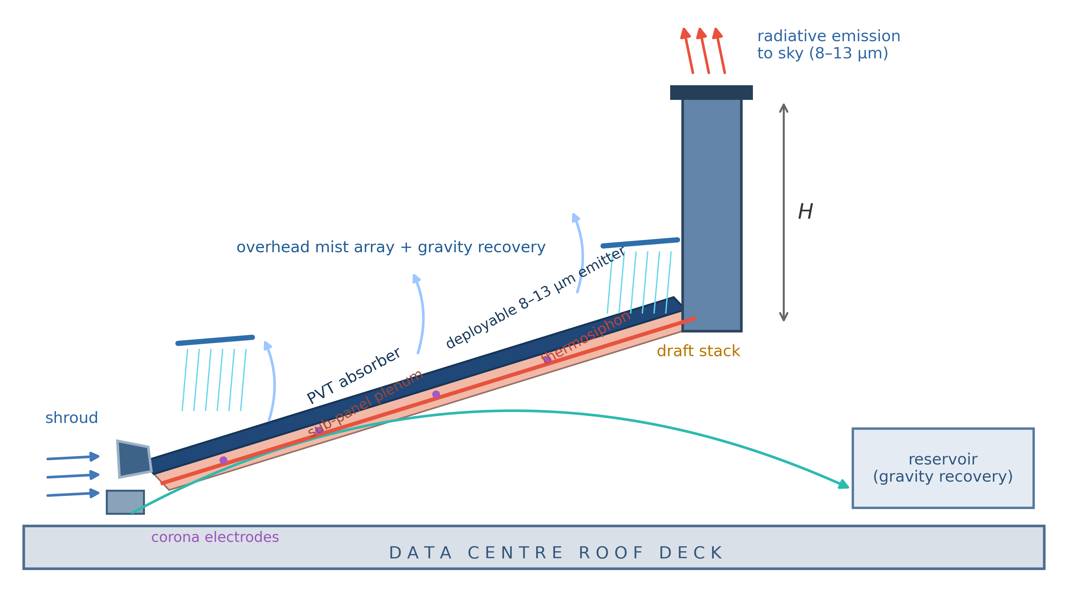
Figure 1. Section through the apparatus showing all seven mechanisms. Waste heat warms the plenum air, which rises through the draft stack of height H and draws cool air in past the aerodynamic shroud at the low edge. A deployable selective emitter radiates through the 8–13 µm window. Corona electrodes in the plenum can induce an ionic wind. Overhead nozzle rows wet the panel surface, and unevaporated water drains to a gutter and returns to the reservoir.

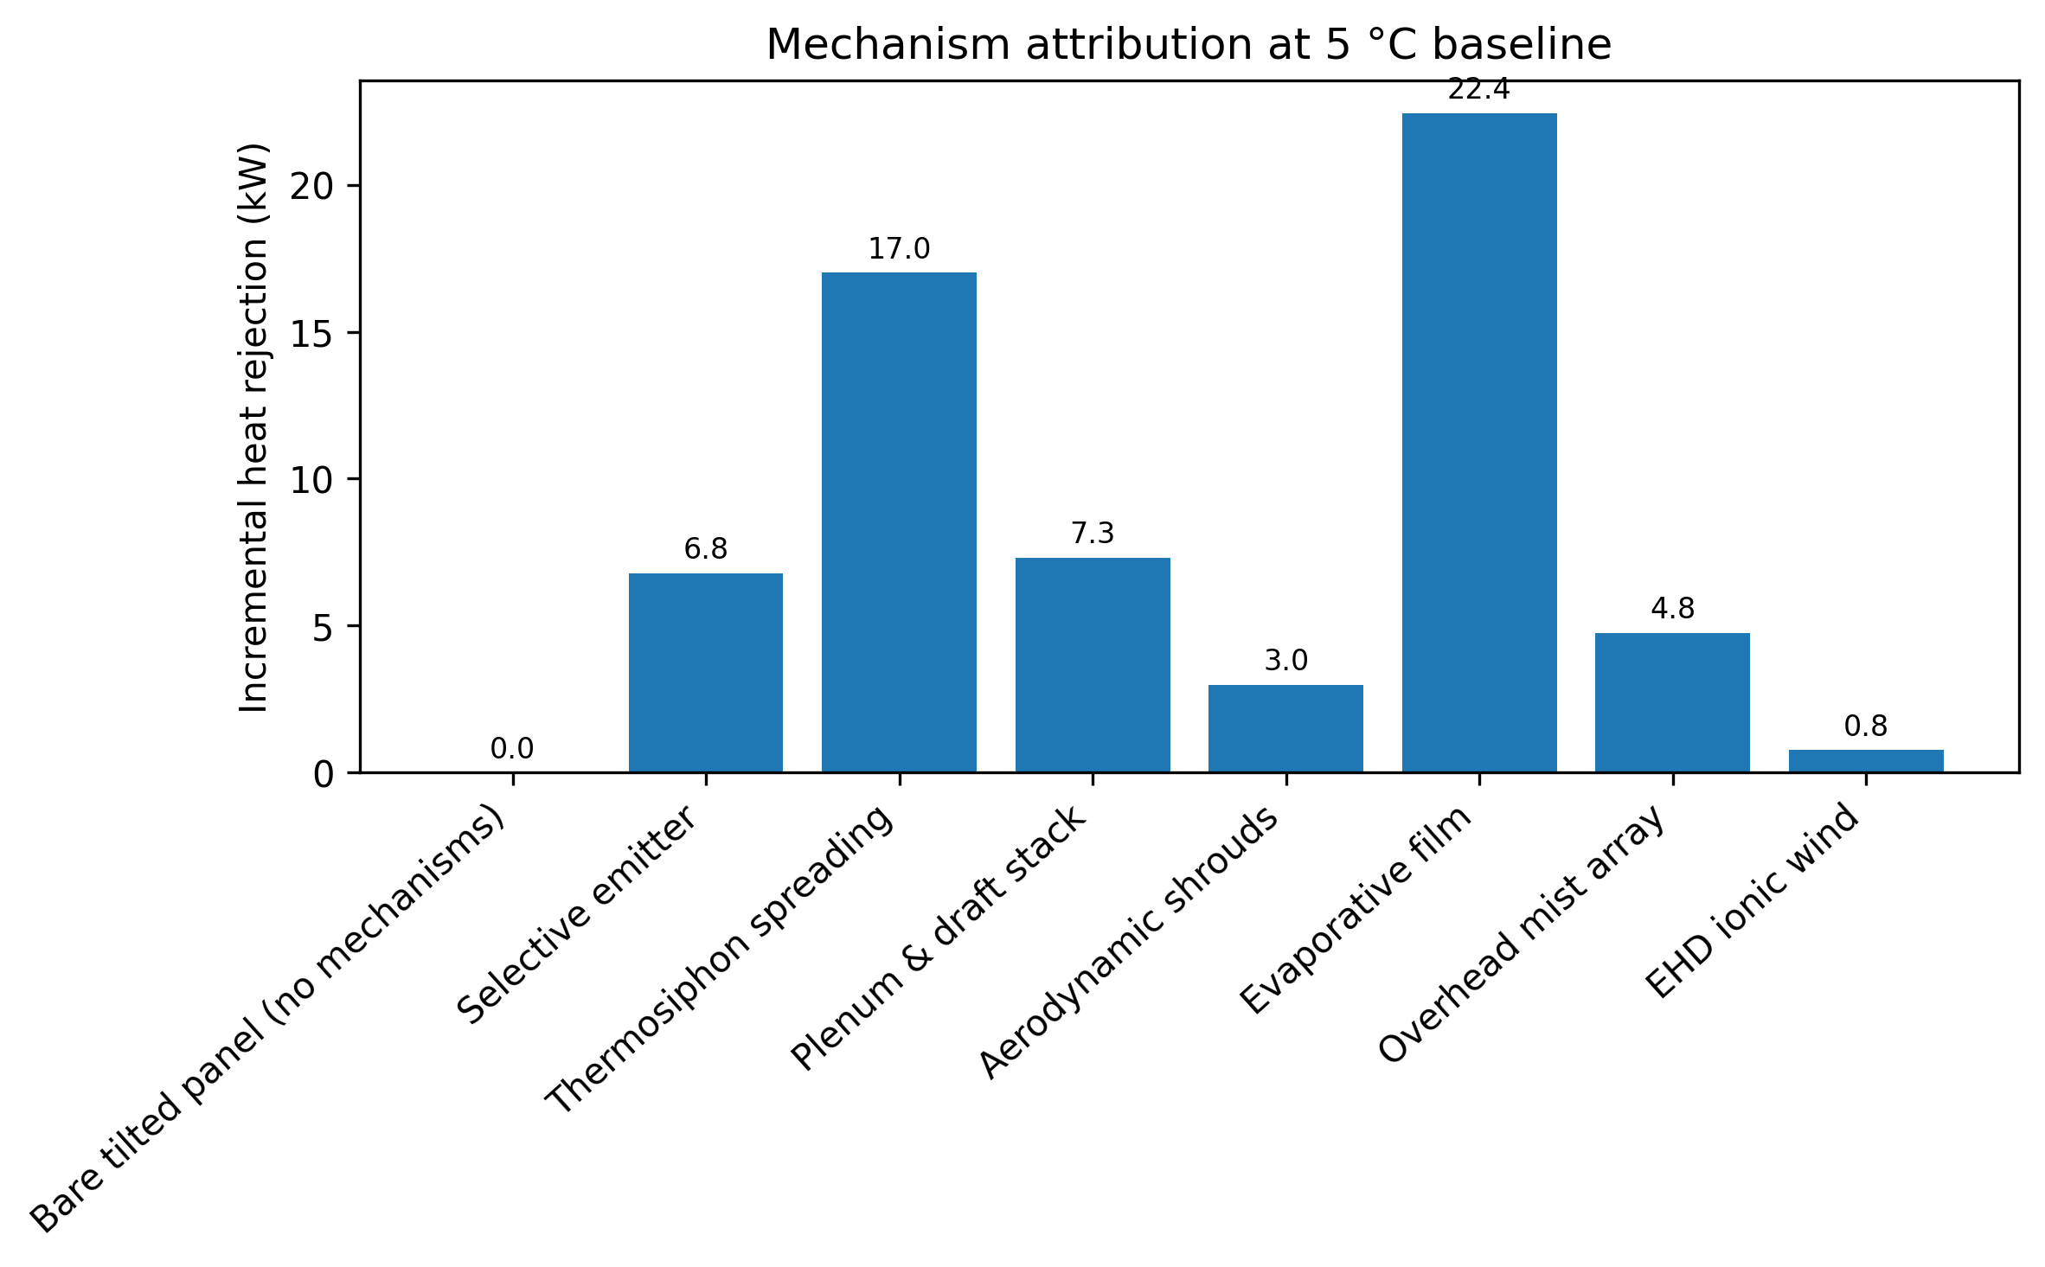
Figure 2. Mechanism attribution at the baseline clear 5 °C night. Bars show the incremental contribution of each mechanism; cumulative modeled capacity rises from 51.2 to 113.2 kW.

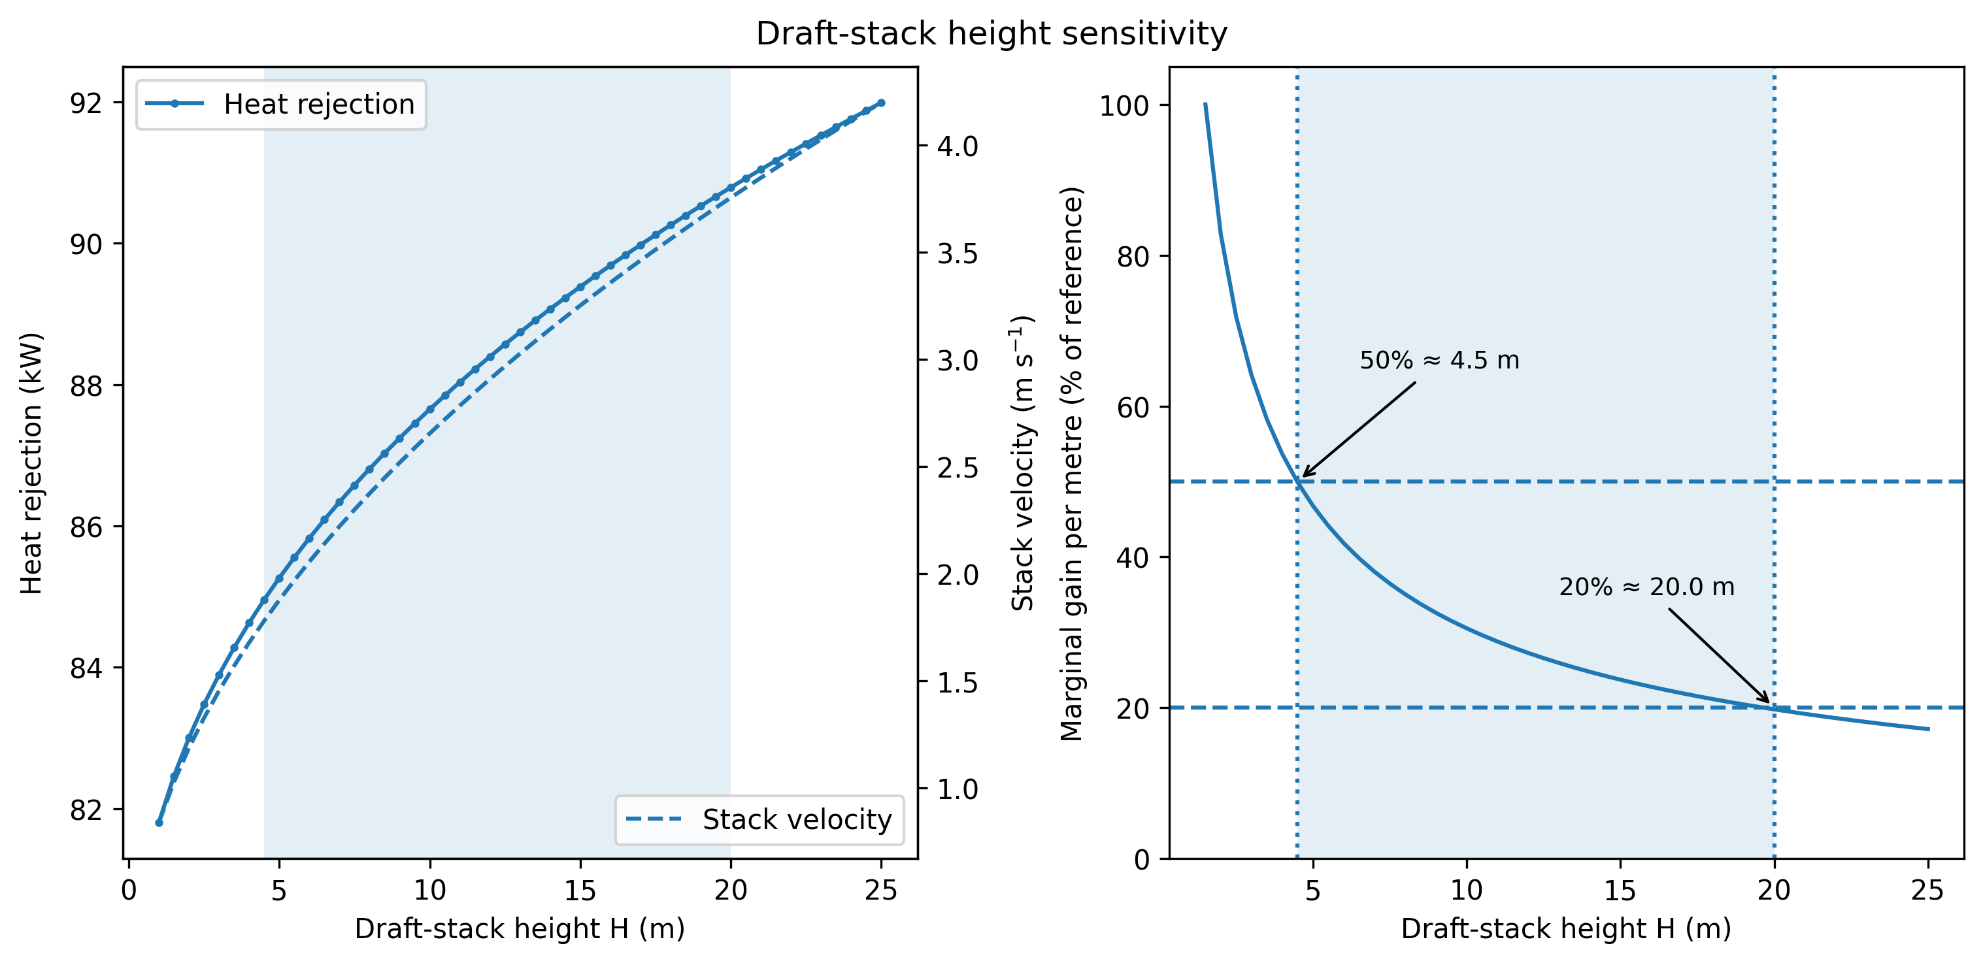
Figure 3. Draft-stack sensitivity. Left: rejection capacity and stack velocity against height. Right: marginal capacity gain per additional meter normalized to the 1.0–1.5 m reference increment; the 0.5 m design sweep reaches 50% at about 4.5 m and 20% at about 20.0 m.

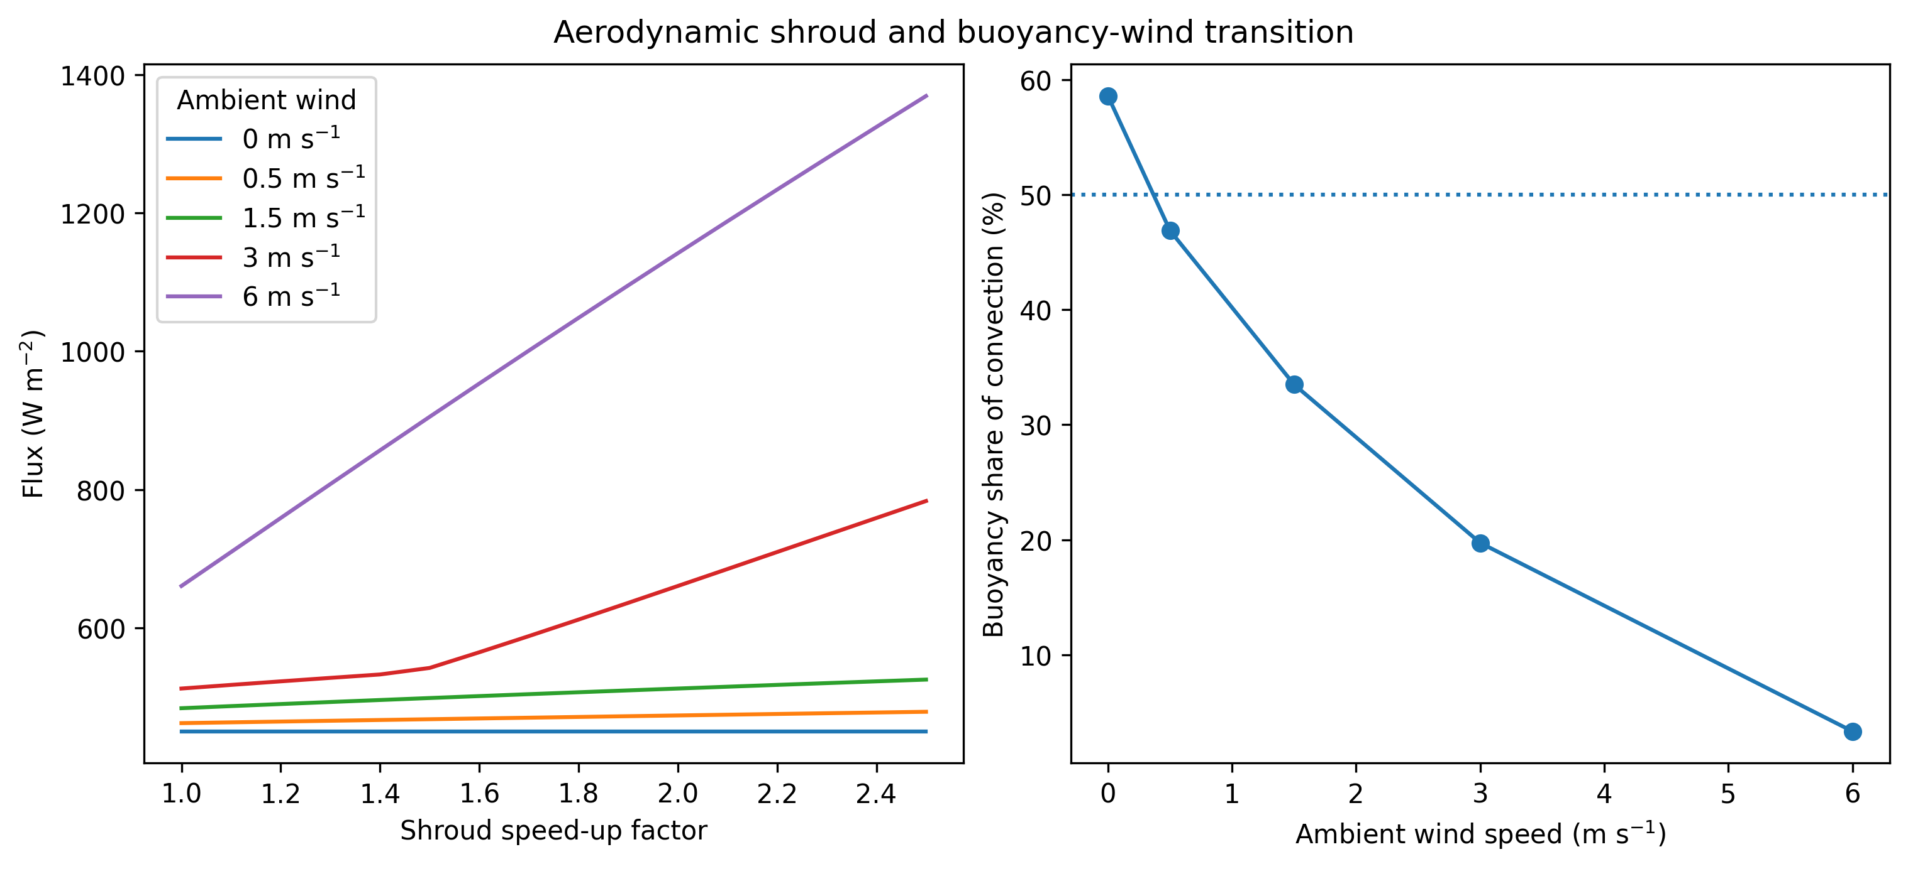
Figure 4. Aerodynamic shrouds. Left: flux against shroud speed-up factor at five wind speeds. Right: buoyancy share of the modeled convective coefficient at the design speed-up, declining from about 59% in still air to about 3% at 6 m s⁻¹.

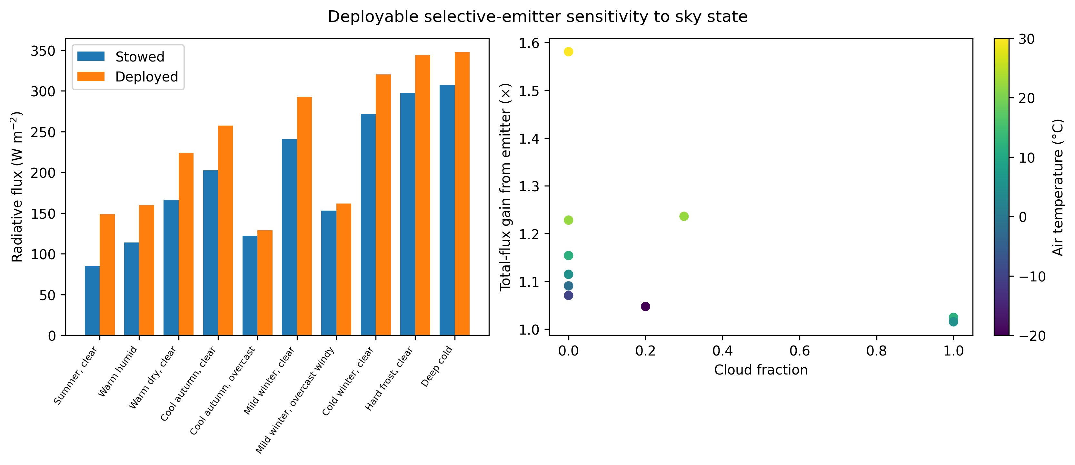
Figure 5. Deployable emitter. Left: radiative flux with the emitter stowed and deployed across ten representative conditions. Right: total-flux gain from deployment against cloud fraction, colored by air temperature.

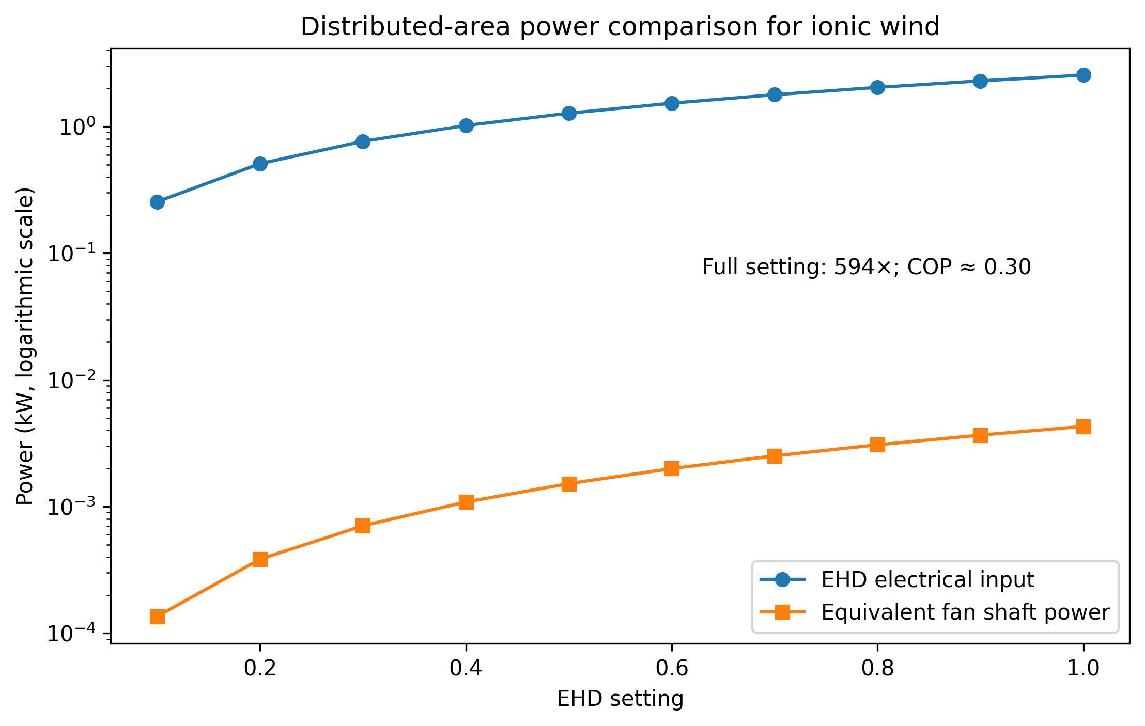
Figure 6. Electrohydrodynamic power comparison on a common 170 m² area basis. At full setting EHD consumes 2.55 kW versus about 4.3 W of idealized equivalent fan shaft power (approximately 594×); the thermal COP at the wet reference point is about 0.30.

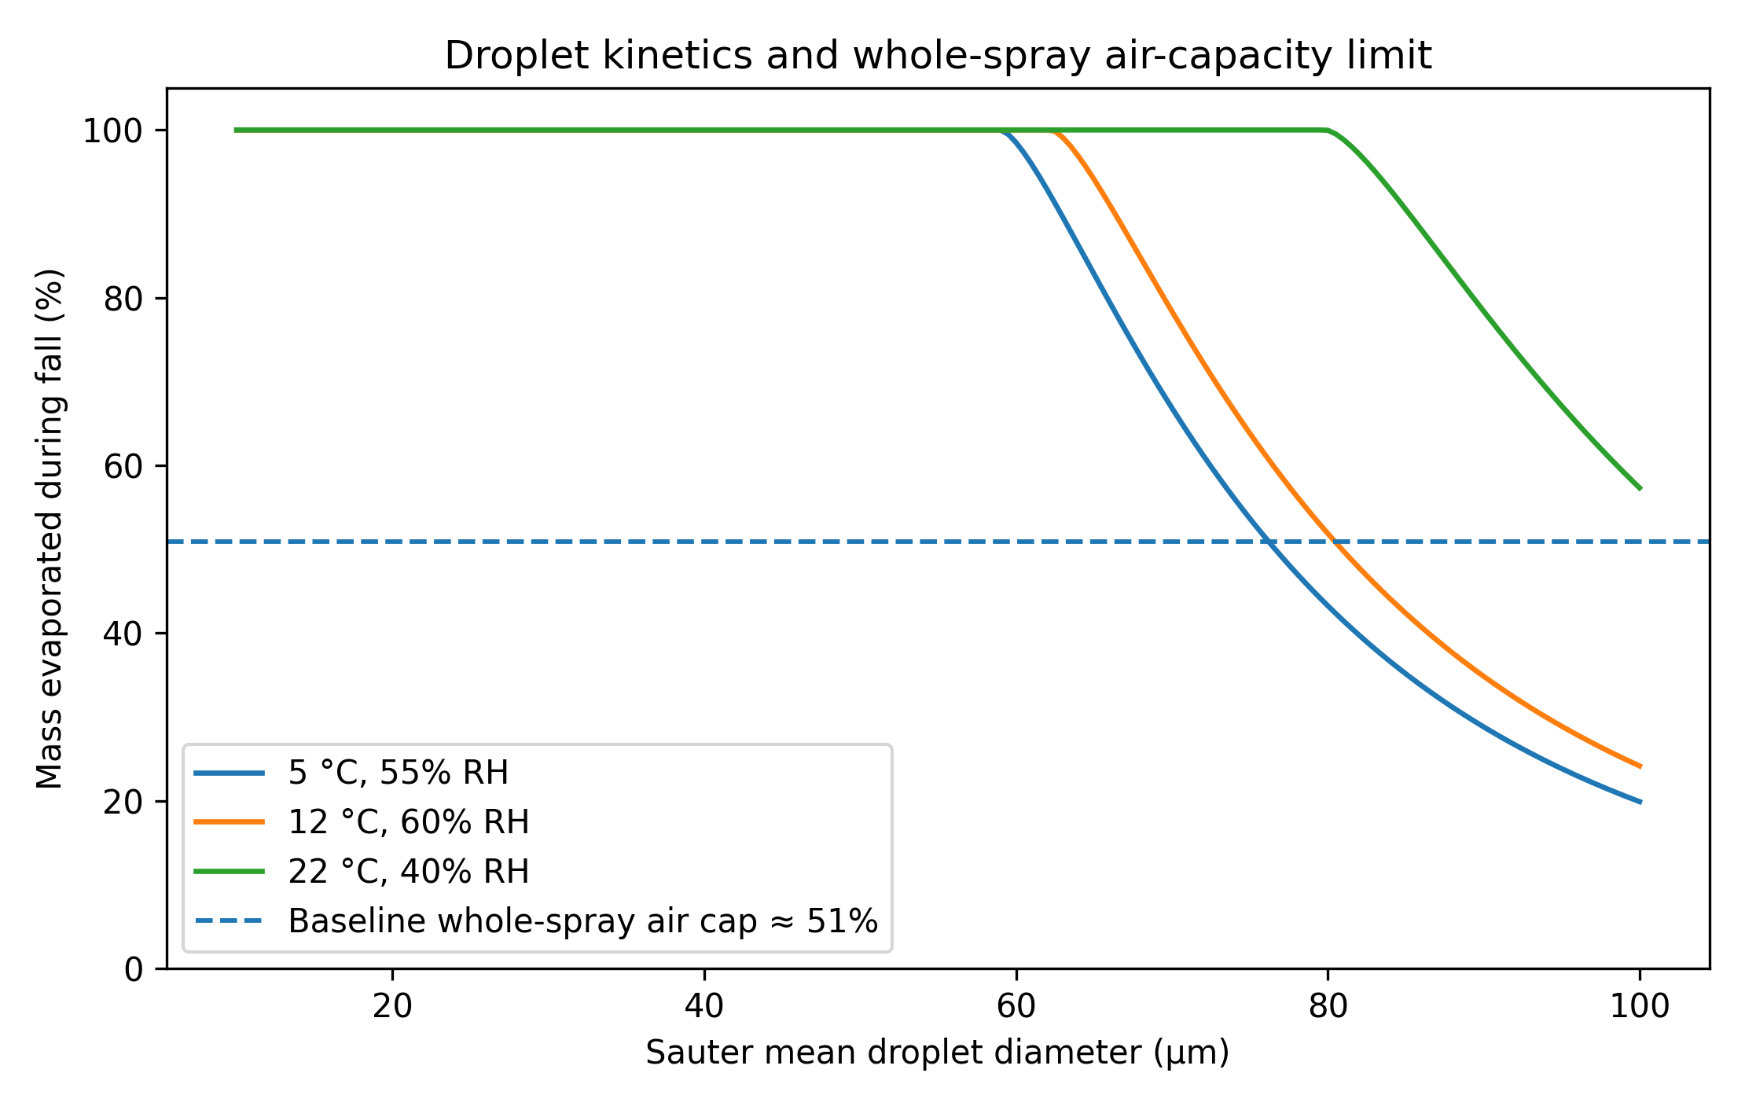
Figure 7. Droplet-flight physics. Isolated-droplet d²-law evaporation is computed with air density; a 45 µm droplet at the baseline condition evaporates in about 7 s, shorter than its approximately 20 s fall. The dashed line shows the separate whole-spray psychrometric cap imposed by the finite moisture capacity of the air renewed through the spray zone.

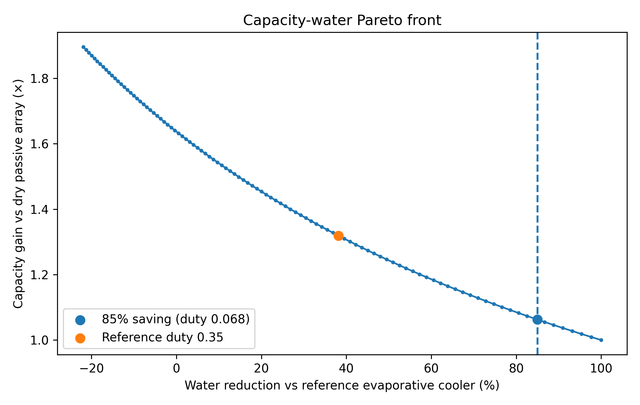
Figure 8. Capacity–water Pareto front from a common film/mist duty sweep. The reference duty of 0.35 gives about 1.32× dry-passive capacity and approximately 38% water saving. An 85% water-reduction target occurs near duty 0.068 and yields about 1.06× capacity.

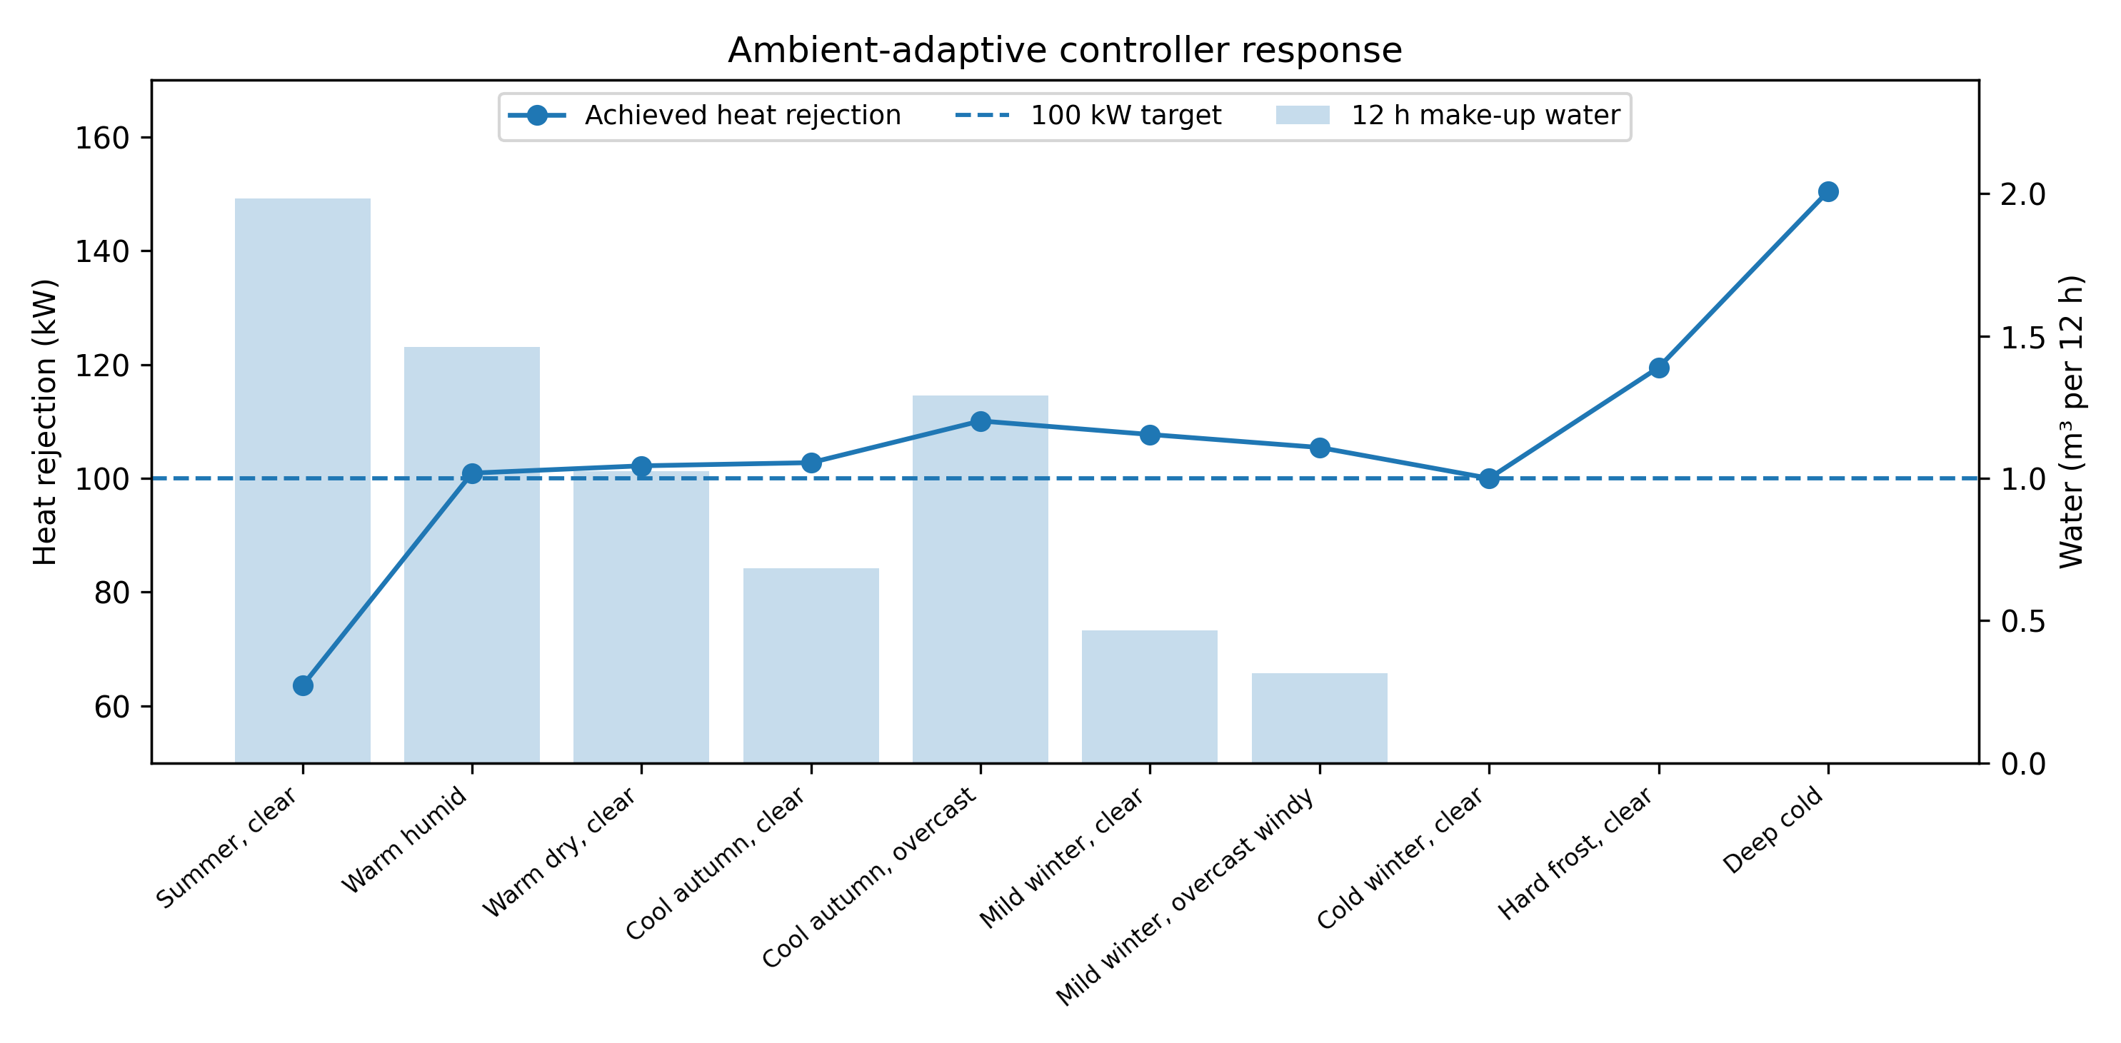
Figure 9. Controller response across ten representative nights. The line gives achieved heat rejection against the 100 kW target and bars give modeled 12 h make-up water. The warm clear summer case remains capacity-limited.

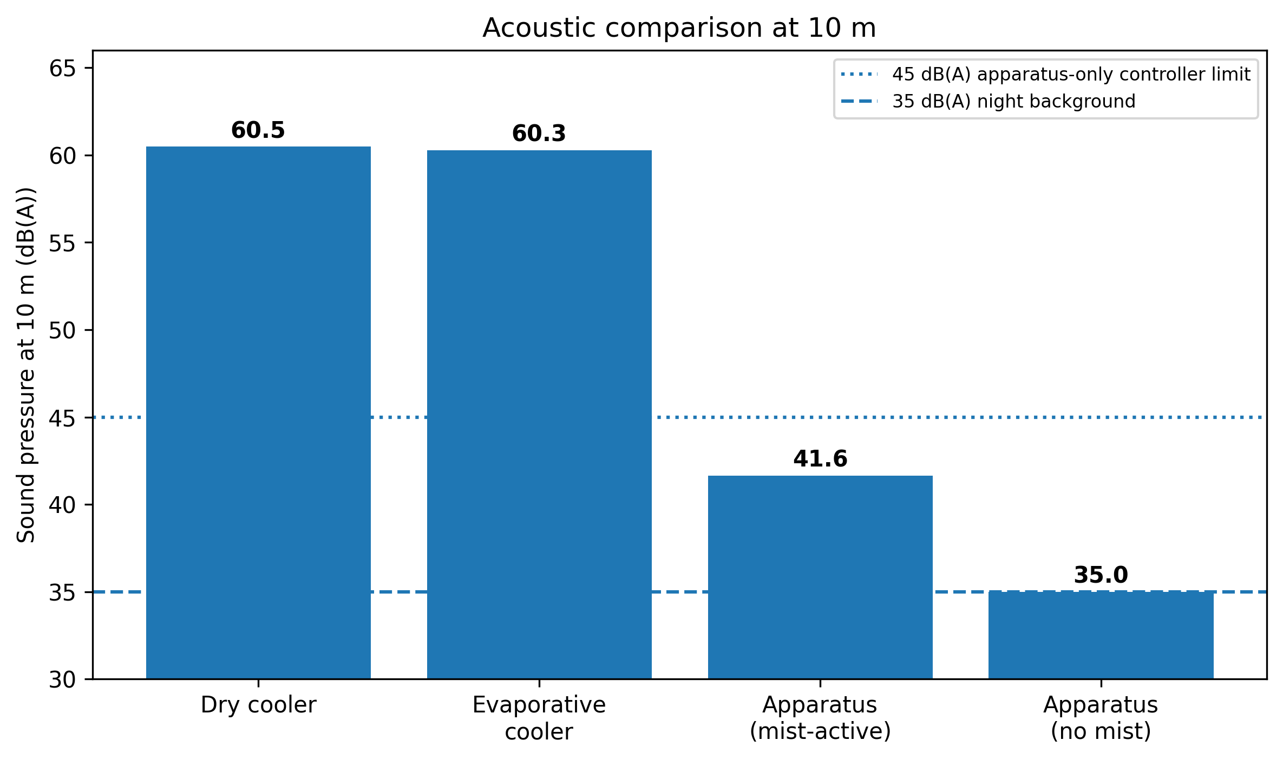
Figure 10. A-weighted sound pressure at 10 m. The mist-active controller modes have a mean total modeled level of about 41.6 dB(A); modes without mist are background-dominated at about 35 dB(A). The 45 dB(A) controller limit applies to apparatus-only sound before ambient background is added.

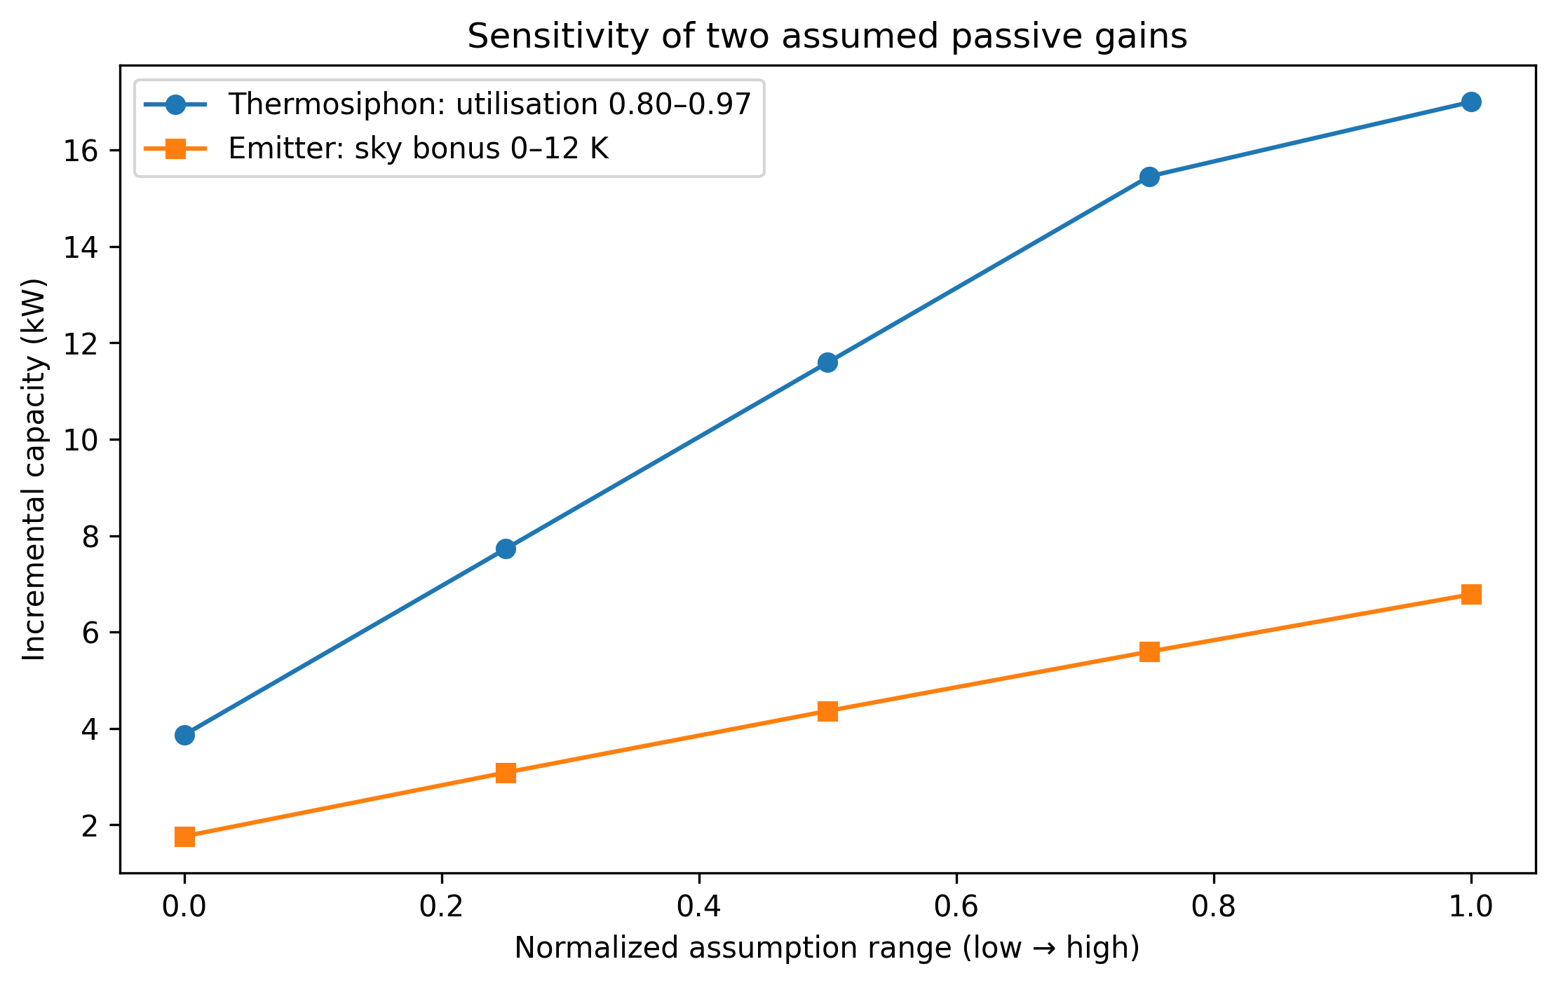
Figure 11. Direct sensitivity of the two largest assumed passive gains. Thermosiphon utilization of 0.80–0.97 changes its increment from about 3.9 to 17.0 kW; selective-emitter sky-temperature bonus of 0–12 K changes its increment from about 1.8 to 6.8 kW.

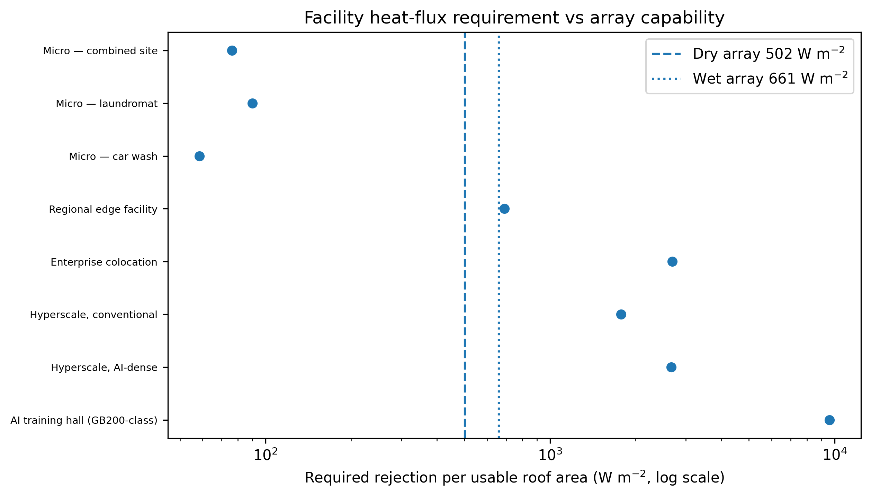
Figure 12. Facility heat-rejection requirement per usable roof area compared with array capability: approximately 502 W m⁻² dry and 661 W m⁻² at the baseline wet reference point.

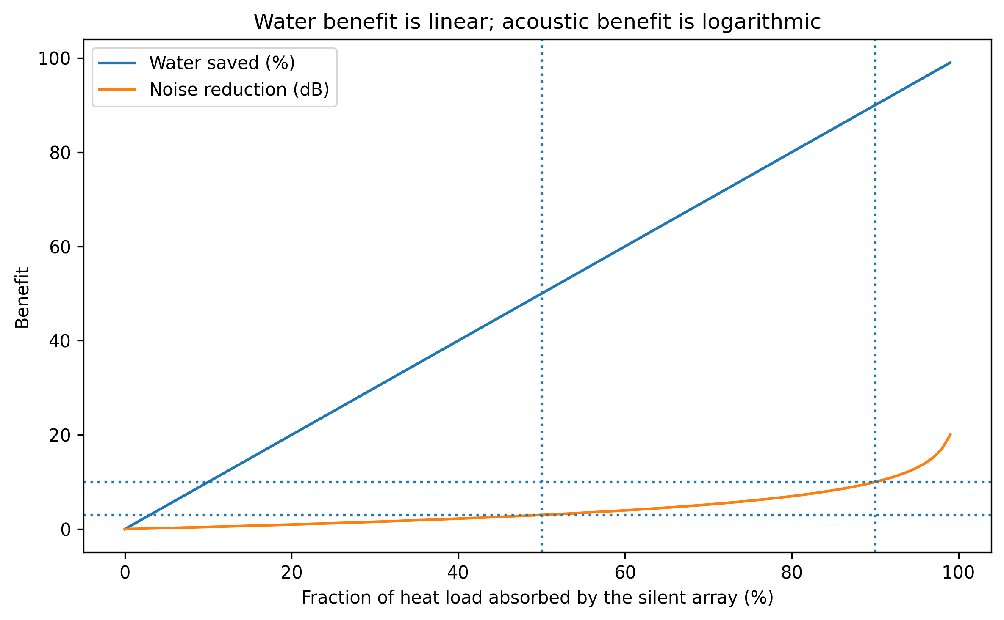
Figure 13. Water saving (linear) and idealized sound-power reduction (logarithmic) against the fraction of heat load absorbed by the silent array. A 3 dB reduction requires 50% coverage and a 10 dB reduction requires 90%.

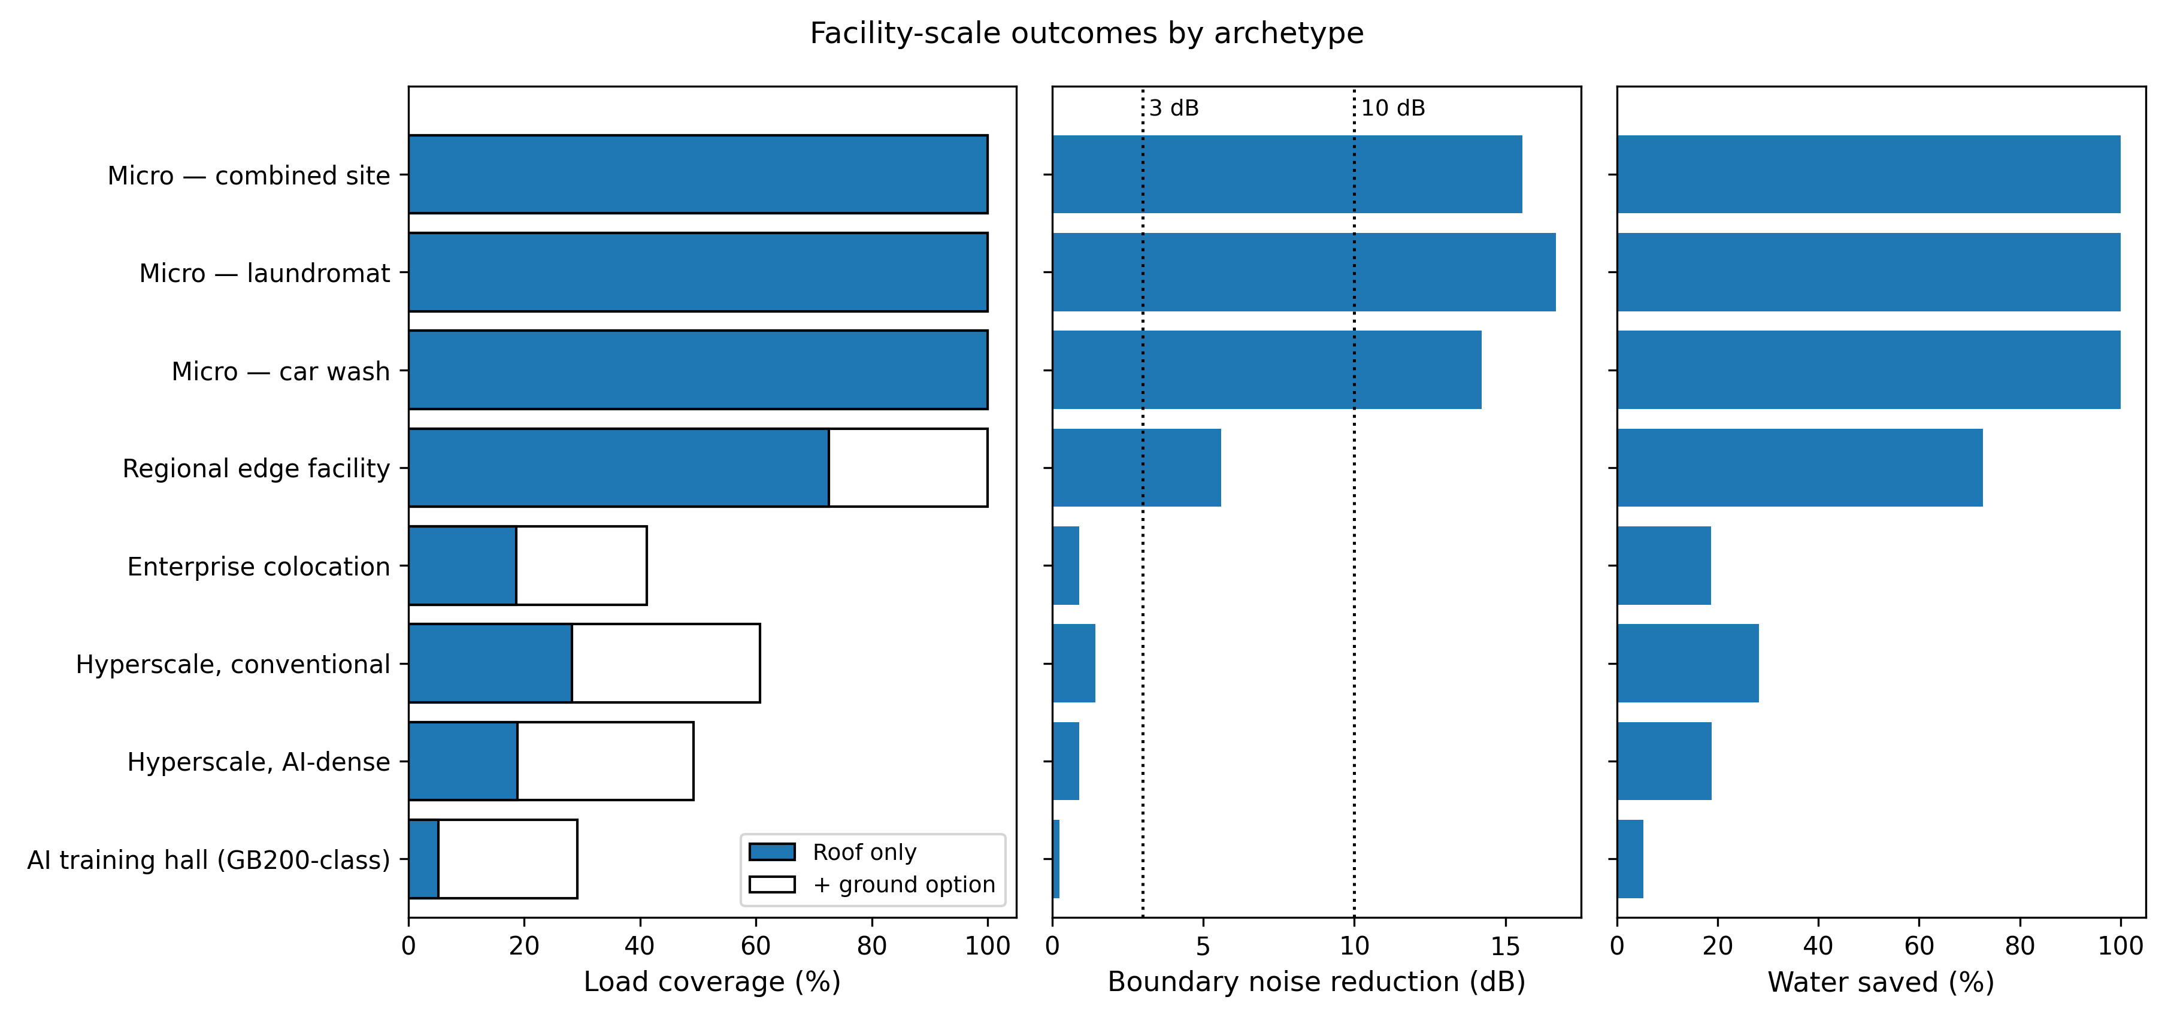
Figure 14. Outcomes by archetype. Left: load coverage, roof-mounted and with ground-mount augmentation. Center: boundary noise reduction against the 3 dB and 10 dB thresholds. Right: water displacement in dry-array operation. The panels illustrate why water and acoustic benefits scale differently.

